DATA VISUALIZATION REPORT

LAB 02: DATA **VISUALIZATION WITH TABLEAU**

GROUP 07

20127449 – Tran Quoc Bao

20127452 – Ho Dang Cao

20127476 – Do Duc Duy

20127567 – Le Nguyen Binh Nam

Instructors

Dr. Bui Tien Len

Dr. Le Ngoc Thanh

Table of Contents

EVALUATIONS 1

LEVEL OF COMPLETION OF REQUIREMENTS 1

LEVEL OF COMPLETION OF MEMBERS 2

DETAILS 3

THEORY 3

A. Introduction 3

B. Features 6

PRACTICE 13

I. Overview and Summary 14

II. Analysis 25

III. Continents 32

IV. Top countries 45

V. Time series (by day) 50

VI. Dashboard 55

VII. Why do we use color for all charts? 56

References 57

# EVALUATIONS

## LEVEL OF COMPLETION OF REQUIREMENTS

|  |  |  |  |
| --- | --- | --- | --- |
| ID | TASK | MEMBER | LEVEL |
| 1 | Scatter chart Relation between Total case and Population | 20127452 | 100% |
| 2 | Scatter chart Relation between total deaths and total recovered | 100% |
| 3 | Pie chart Percent by continent Charts (4 charts) | 100% |
| 4 | Bar charts top 10 countries (5 charts) | 100% |
| 5 | Overview of tableau | 20127567 | 100% |
| 6 | Advantages and disadvantages of tableau | 100% |
| 7 | Some of the main functions in tableau | 100% |
| 8 | Demo some simple charts | 100% |
| 9 | Bar chart Global situation of Covid-19 epidemic | 20127476 | 100% |
| 10 | Heat map Global situation of Covid-19 epidemic | 100% |
| 11 | Multiple scatter chart Relationship between total cases and others | 100% |
| 12 | Scatter chart Relationship between serious and active cases | 100% |
| 13 | Bar mix line chart Review of total cases | 100% |
| 14 | Bar mix line chart Review of total deaths | 100% |
| 15 | Bar mix line chart Review of total recovered | 100% |
| 16 | Bar mix line chart Review of total tests | 100% |
| 17 | Multiple bar chart Ratio of case-test-death in each continent | 100% |
| 18 | Bar chart Top 20 countries with the most ratio of cases per population | 100% |
| 19 | Bar mix line chart Change of total cases | 100% |
| 20 | Bar mix line chart Change of total deaths | 100% |
| 21 | Bar mix line chart Change of total recovered | 100% |
| 22 | Symbol maps Total case in the word | 20127449 | 100% |
| 23 | Side by side bars Covid-19 by continent | 100% |
| 24 | Bar chart and line chart Total case and Total recovered by countries in continent | 100% |
| 25 | Bar chart and line chart Total case and total deaths by countries in continent | 100% |
| 26 | Dashboard | 100% |
| 27 | Bar chart top 10 total deaths | 100% |

## LEVEL OF COMPLETION OF MEMBERS

| ID | FULL NAME | LEVEL |
| --- | --- | --- |
| 20127449 | TRAN QUOC BAO | 100% |
| 20127452 | HO DANG CAO | 100% |
| 20127476 | DO DUC DUY | 100% |
| 20127567 | LE NGUYEN BINH NAM | 100% |

# DETAILS

## THEORY

### Introduction

* **Tableau** is a software that supports data analysis and visualization, widely used in the field of Data Analyst to build a digital platform and analyze data for businesses.
* **Some of Tableau's main functions:**
  + Connect and retrieve data: Tableau allows you to connect and retrieve data from a variety of sources, including databases, files, and cloud applications.
  + Create dashboards: Tableau allows creating dashboards by dragging and dropping items and provides many customization options for dashboard formatting.
  + Data analysis: Tableau provides a variety of data analysis tools to help users better understand their data, including charts, graphs, and maps.
  + Create maps: Tableau allows you to create maps and perform analysis on maps, including geomaps and heat maps.
  + Integration with other tools: Tableau can integrate with many other tools, including Excel, R, and Python.
  + Sharing and publishing: Tableau allows dashboards, maps, and reports to be shared with other members of the organization or publicly on the web. In addition, Tableau also allows exporting dashboards and reports to various formats such as PDF, Excel and CSV.
  + Automation: Tableau provides automation to help users save time and effort in data processing.
* **Using Tableau for data analysis and data visualization has many benefits, including:**
  + Present data in an intuitive and easy-to-understand way: Tableau allows data to be presented with charts, graphs, and maps, helping users better understand their data and make decisions faster.
  + Analyze data quickly and accurately: Tableau provides a variety of data analysis tools to help users analyze data quickly and accurately.
  + Speed up data analysis: Tableau allows connecting and retrieving data from a variety of sources and automates analysis steps, saving time and effort.
  + Increase interoperability and collaboration: Tableau enables dashboards, maps, and reports to be shared with other members of the organization or publicly on the web, facilitating collaboration and interaction among members.
  + Make more efficient and accurate decisions: Using Tableau helps users make more accurate and efficient decisions by making information and data intuitive and easy to understand.
  + Save costs and increase performance: Tableau helps save costs and increase performance by automating data analysis steps, helping to reduce reliance on data experts.
* **Besides the above advantages, Tableau also has some disadvantages:**
  + Cost: Tableau is a relatively expensive piece of software, especially for small and medium businesses.
  + Ability to handle large data: While Tableau can handle large data sets, it can become slow and inefficient for slightly larger data sets.
  + Complexity when using multiple data sources: When multiple data sources are used, combining them in Tableau can become difficult and complex.
  + No programming support: Tableau does not support programming languages other than the custom command line, which can make customization difficult.
  + Difficult to use for beginners: With its powerful features, Tableau can become difficult to use for beginners or inexperienced with data analysis and visualization.
  + No support for complex data: Tableau does not have the features to support complex data like traditional database management systems (DBMS). This can make it difficult to implement features like primary key management, foreign key management, table management, relationship management between tables.
* **All in all**, these limitations shouldn't be a big deal for many Tableau users, as it's still a powerful and popular BI software widely used in many fields and industries. Using Tableau for data analysis and data visualization boosts performance, saves costs, and helps users make more efficient and accurate decisions.
* **Install Tableau**:
  + Visit <https://www.tableau.com/> to download the installer.
  + Launch the installation and follow the software instructions.

### Features

1. **Select the data table and create the Worksheet:**

* Tableau allows creating and selecting interconnected data sheets, different sheets in a specific data file, connection modes of data tables, and users can customize for manual connections.

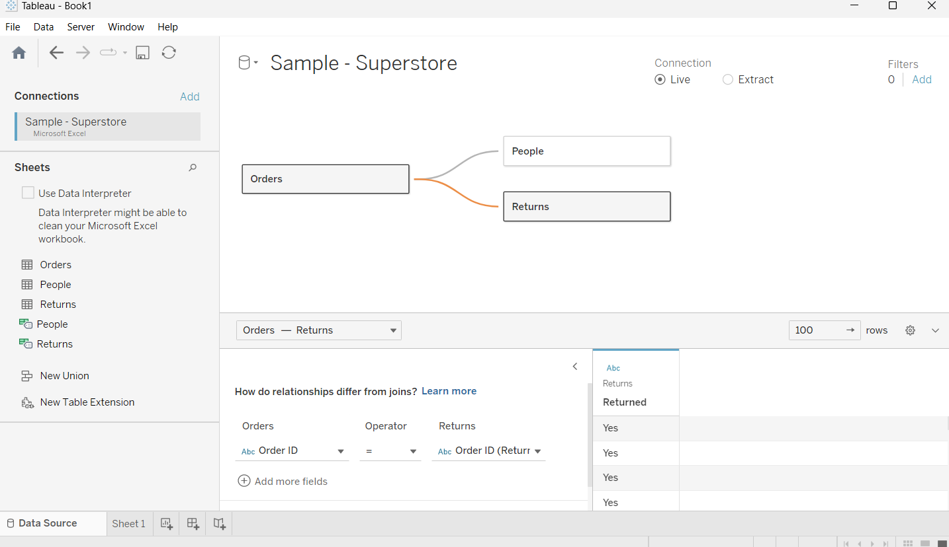

Note: data provided by Tableau (Sample - Superstore)

* To visualize that data, Tableau provides worksheets, the components of which include the following main sections:
  + Tools commonly used in chart configuration:



* Data & Analytics Framework. Divided into 2 tabs:
  + The Data tab contains the data fields in the dataset:

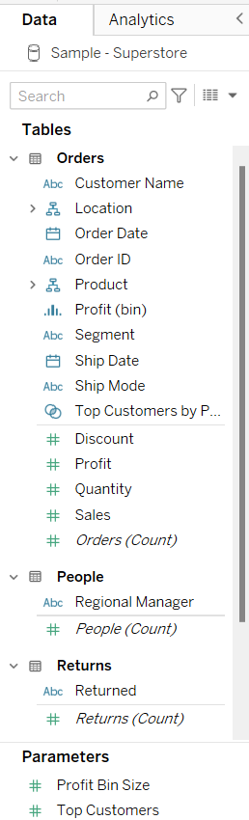

* The Analytics tab contains basic data analysis including: Summary analysis (representing constant lines, mean, median, ...); Algorithmic analysis (trend representation, prediction, clustering, ...); Other analytics (user-defined):

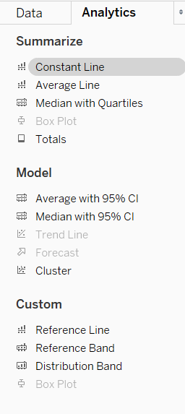

* Filter and mark data:

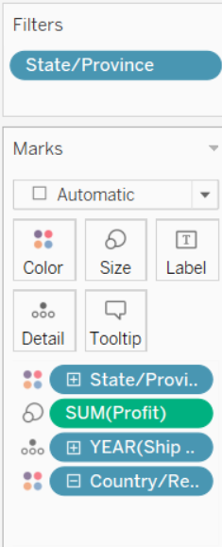

* The data container is visualized, including 2 frames: Rows and Columns:

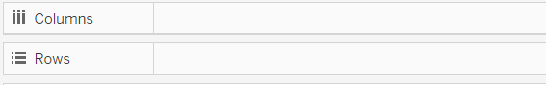

* Chart container:

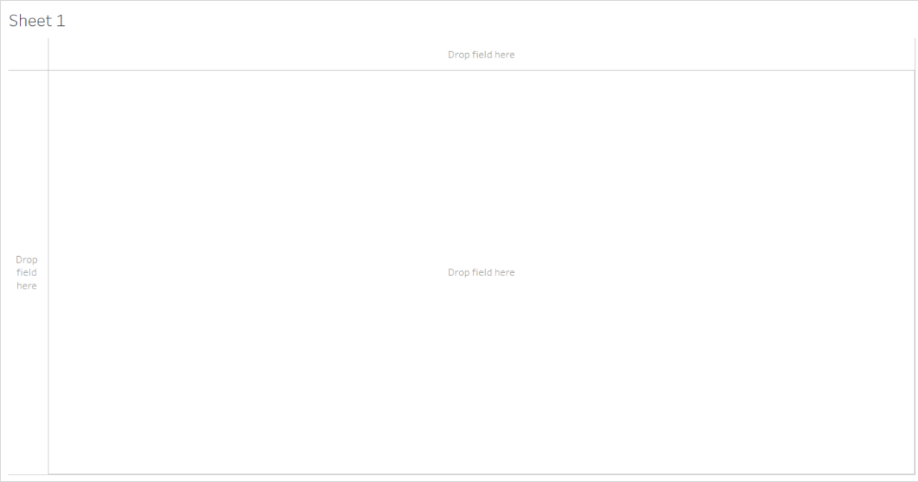

1. **Draw some basic chart types:**
   1. Column chart:

* A column chart is a type of statistical chart used to display data as vertical columns. Each column represents a value or a group of values in the data set.
* The chart below shows the profitability of each product category by country.

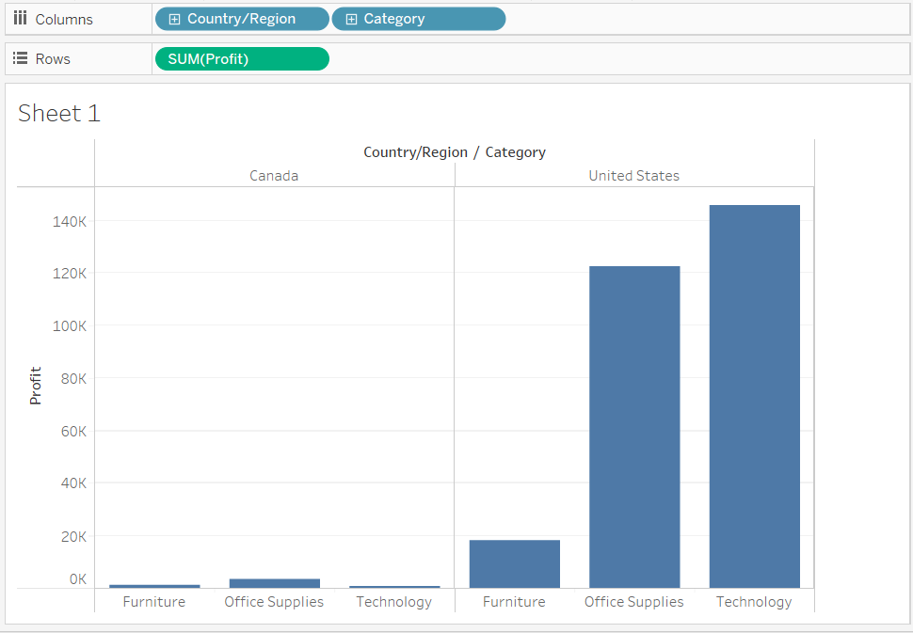

* Measurements can be customized. In addition, you can adjust the color, add labels to the columns of the chart. These adjustments can be applied to many different types of graphs, but must satisfy the representation logic.

1. Line graph:

* A line chart is a type of statistical chart that uses a continuous line to represent the change of a data set over a period or number line. Line charts are often used to represent the trend and volatility of a data set over a certain period of time.
* The following chart shows the country's profits by year:

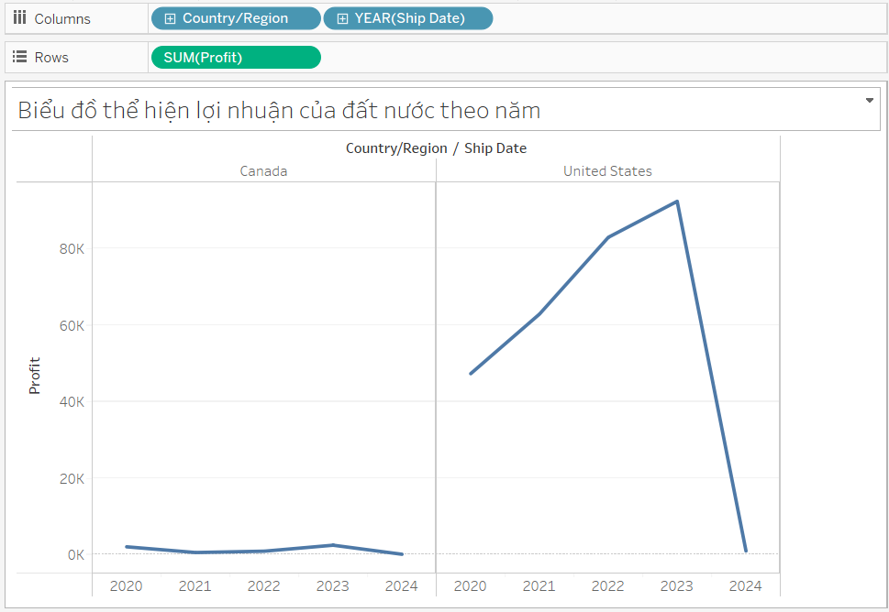

1. Map representation based on landmarks or geographic coordinates:

* The chart below shows the highest profits for each state in the US and Canada for the year:

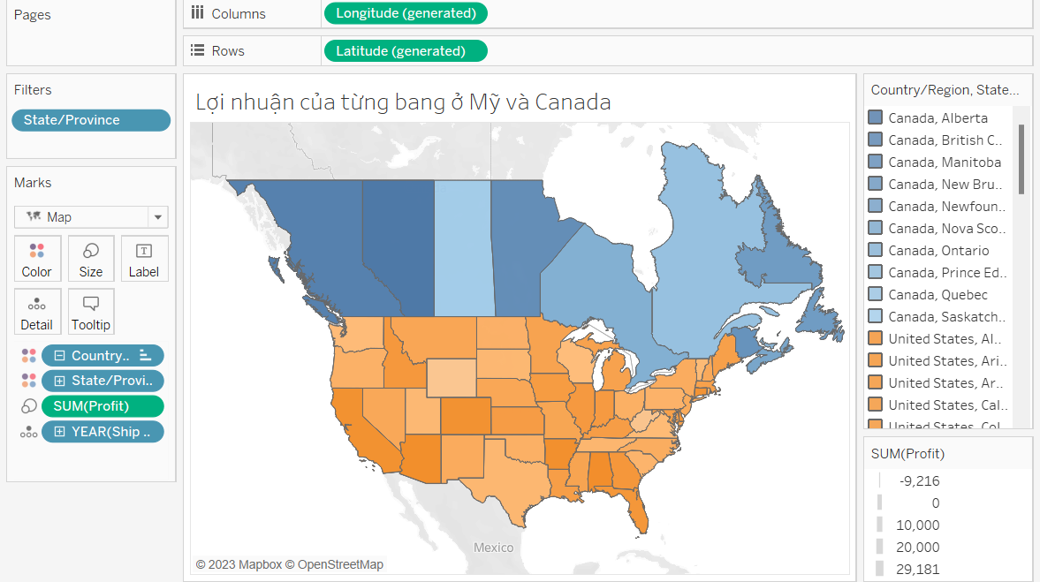

1. **Dashboard & story:**
   1. Dashboard:

* Dashboard in Tableau is a tool that allows you to aggregate and visually present information from various data sources in a single web page. It allows you to combine different types of charts, tables, and images to create a complete picture of the data and help users analyze and better understand the data.
* Dashboard in Tableau gives users the ability to customize and design dashboard pages according to their needs. Users can freely create different types of charts, edit the color, size and data type displayed on the dashboard page.
* Example dashboard illustration:

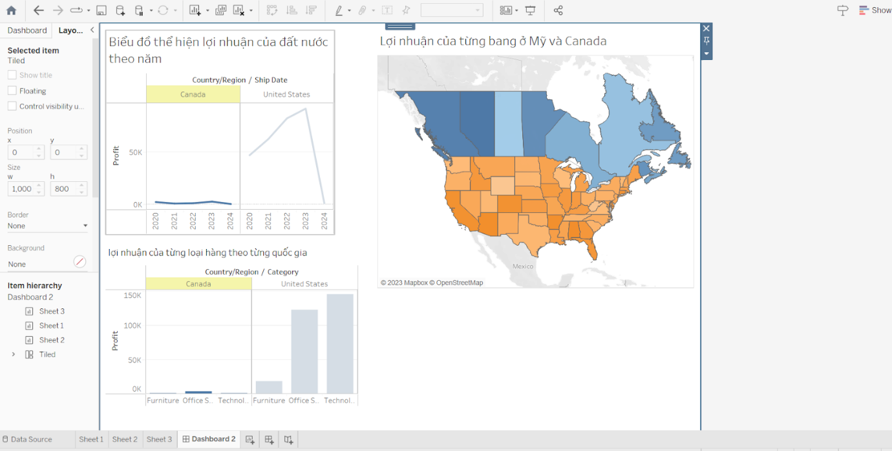

1. Story:

* Story is a series of images that work together to convey a message, a story.
* You can create stories to tell a data story, provide context, demonstrate how decisions relate to outcomes, or make a compelling case.

1. **Some other features:**

* Large data import, metadata management.
* Support for creating queries with a simple dummy operation.
* Analyze data with BigData.
* Shared real-time analytics, connected through real-time online applications.

## PRACTICE

In this section, we use the data that crawled from lab 01.

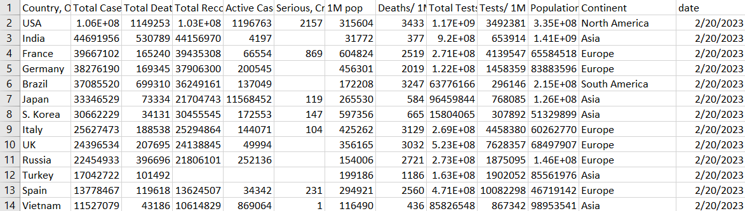

* Data is collected in 7 days, and add Date attribute to data.
* Merge all data files by date into 1 overall file.

**Note that**: our data frame now has 16 columns.

### Overview and Summary

1. Total case in the word

**Chart**

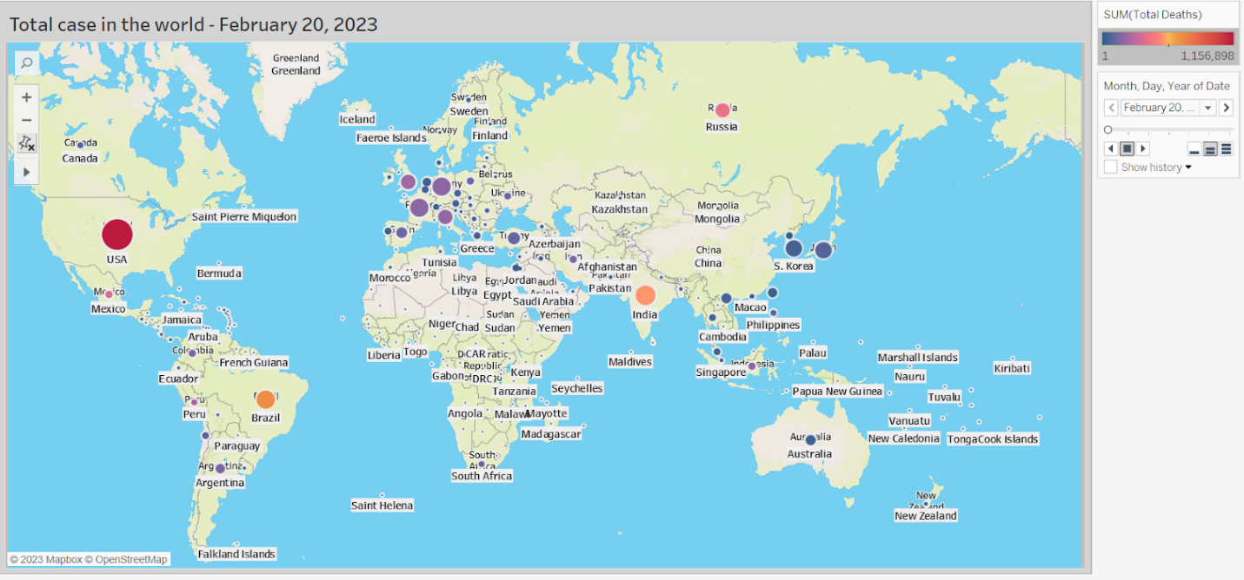

**How to do**

* Select Country, other and total case tables then select symbol maps in show me.

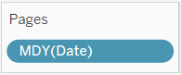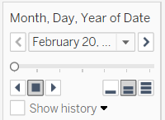

* Set date for pages: format date: Month - date - year

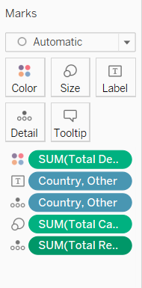

* Size: Total case, the larger the total case, the bigger the circle
* Detail: Total Recovered; Country, Other.
* Color: Total Deaths
* Label: Country, Other
* Set Background: Select Map -> Background Maps ->Streets

**Comments**

* The chart shows the situation of covid 19 around the world
* The circles represent the total cases of the countries, the larger the circle, the more total cases.
* The color of the circle shows the total deaths of countries, the darker color shows the more total deaths
* When hovering over the circles, the country's covid-19 information will appear.

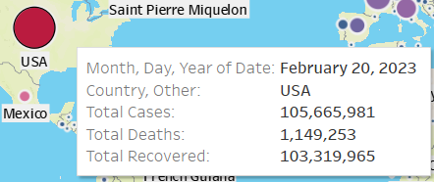

1. Covid-19 by continent

**Chart**

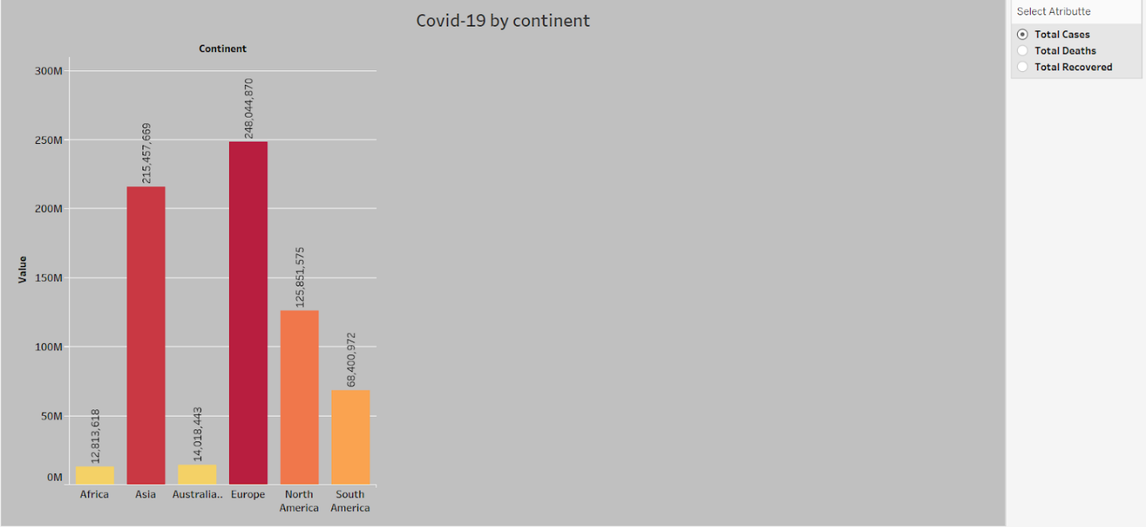

**(Covid-19 by continent 1)**

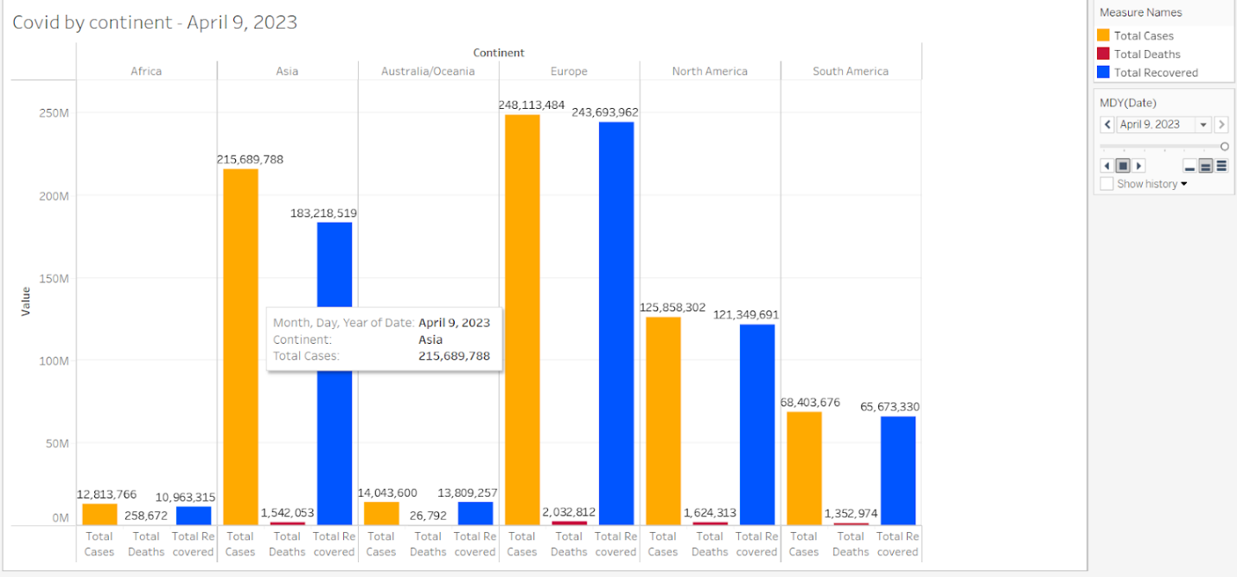

**(Covid-19 by continent 2)**

**How to do**

* **Covid-19 by continent 1 is used dashboard**
* 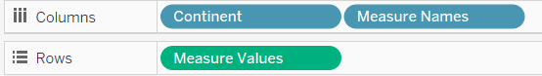
* Set columns: Continent, Measure Names.
* Row: Measure Values
* 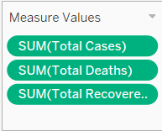 **:** Measure values: total Cases, total deaths, total recovered

**Comments**

* Show the different situation of covid-19 epidemic between continents
* Europe and Asia have a more severe Covid-19 epidemic situation than the rest of the continents
* Europe has the most total deaths of any continent
* Asia's lowest recovery rate of any continent
* The use of color helps to distinguish values in the chart

1. Total case and total recovered by countries by continent

**Chart**

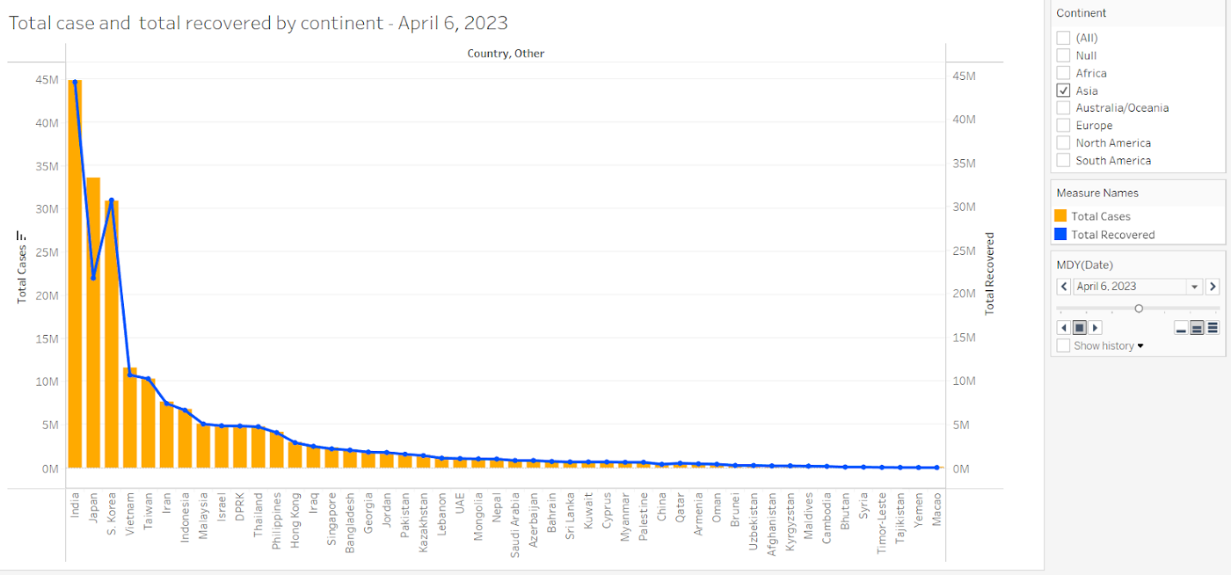

**How to do**

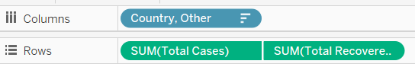

* Set columns: Country, Other.
* Rows: Total Case, Total recovered
* 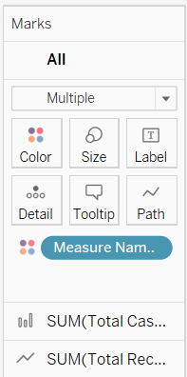:  select 2 chart line and bar chart
* 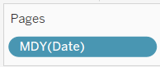: format: Month-Day -Year

**Comments**

* The bar chart represents the total case value, and the line chart represents the total recovered value.
* Shows the covid-19 situation of countries in the same continent.
* Show total recovered on total cases by country.
* Show total case and total recovered by country in the same continent.
* Chart is sorted by total case.
* In most countries total recovered is almost as high as total case.
* The use of color helps to distinguish values in the chart.

1. Covid-19 Summary

**Chart**

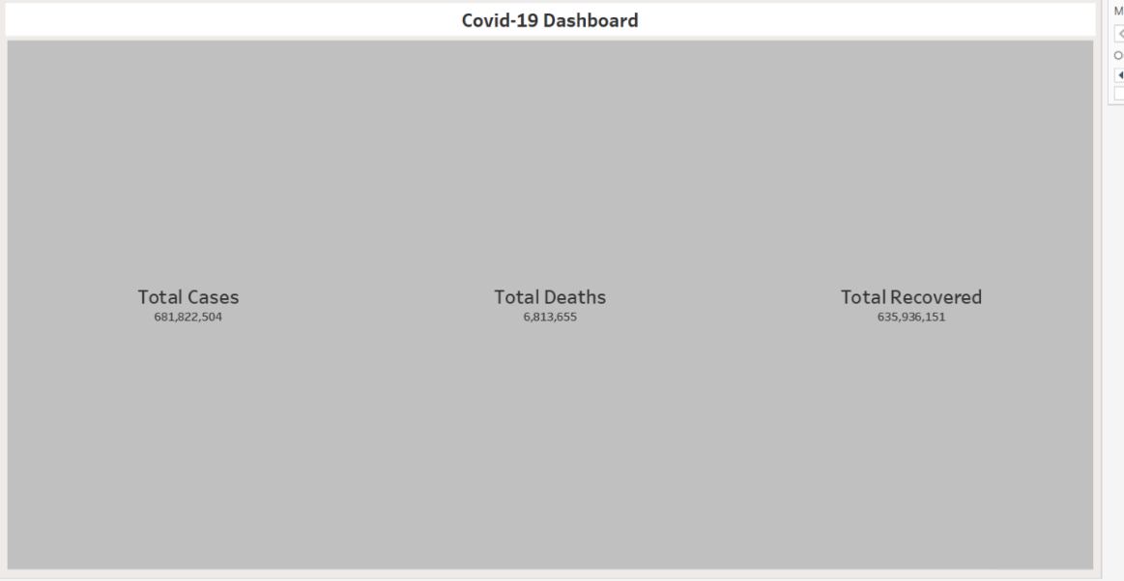

**How to do**

* 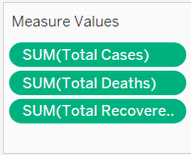Measure value: total case, total deaths, total recovered
* 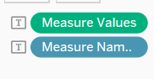: set label is measurename and measure value
* Use format -> shading: set color background

**Comments**

* Use to make dashboard
* Shows total case, total deaths, total recovered in the world

1. Total case and total recovered by countries by continent

**Chart**

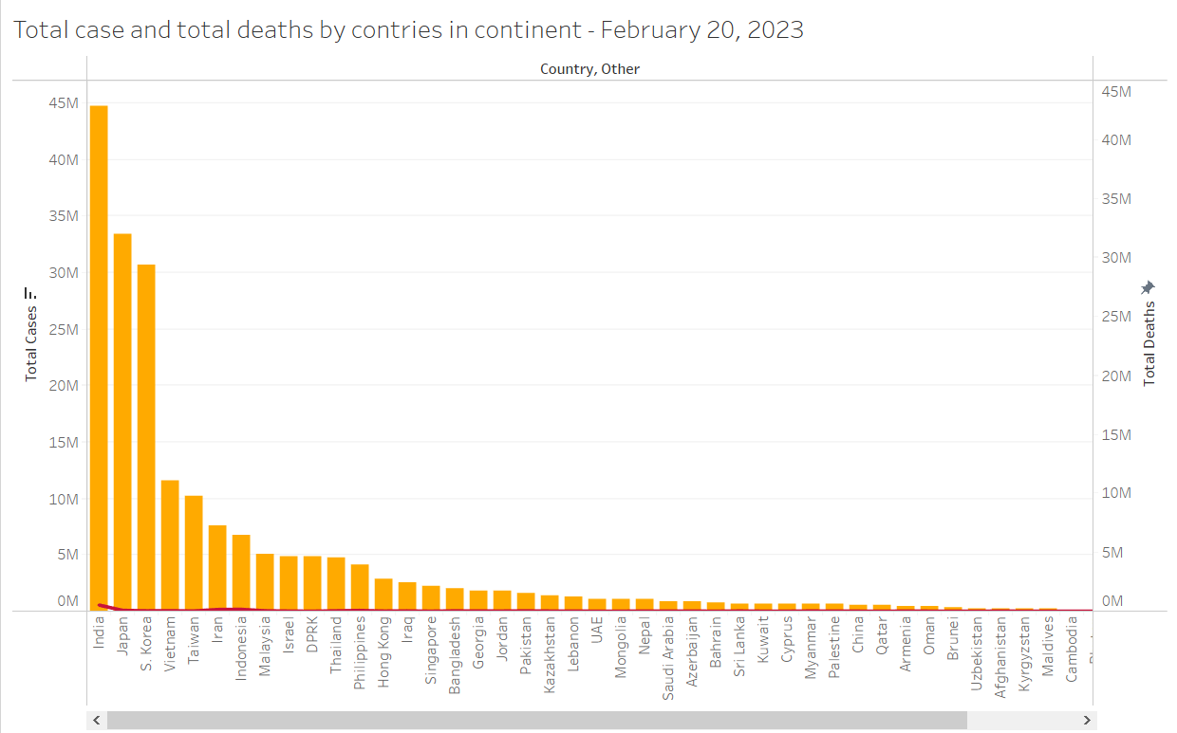

**How to do**

* 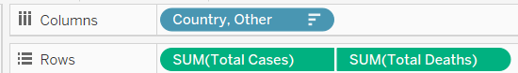
* Set Columns: Country, Other.
* Row: Total cases and Total Deaths.
* 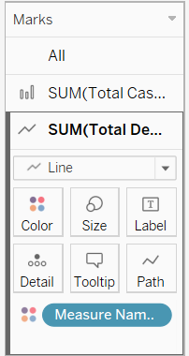 : select 2 chart line and bar chart
* : format: Month - Day -Year

**Comment**

* The bar chart represents the total case value, and the line chart represents the total deaths value.
* Shows the covid-19 situation of countries in the same continent.
* Show total deaths on total cases by country.
* Show total case and total deaths by country in the same continent.

1. Bar chart Global situation of Covid-19 epidemic

**Chart**

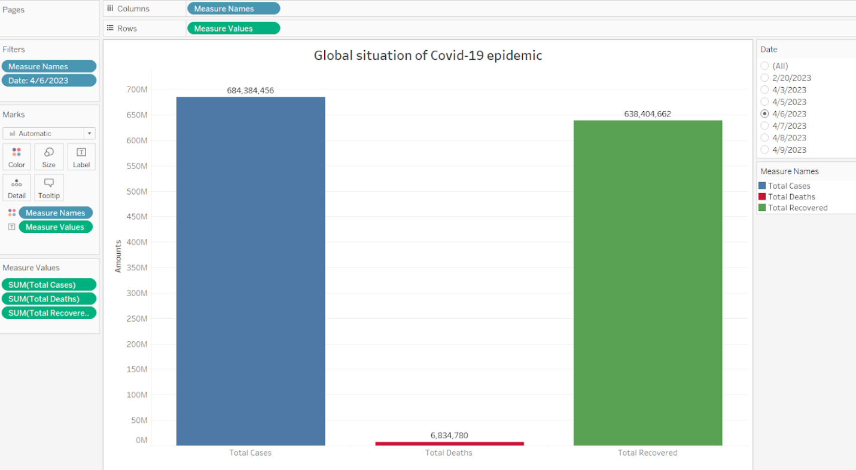

**(Full view of editing)**

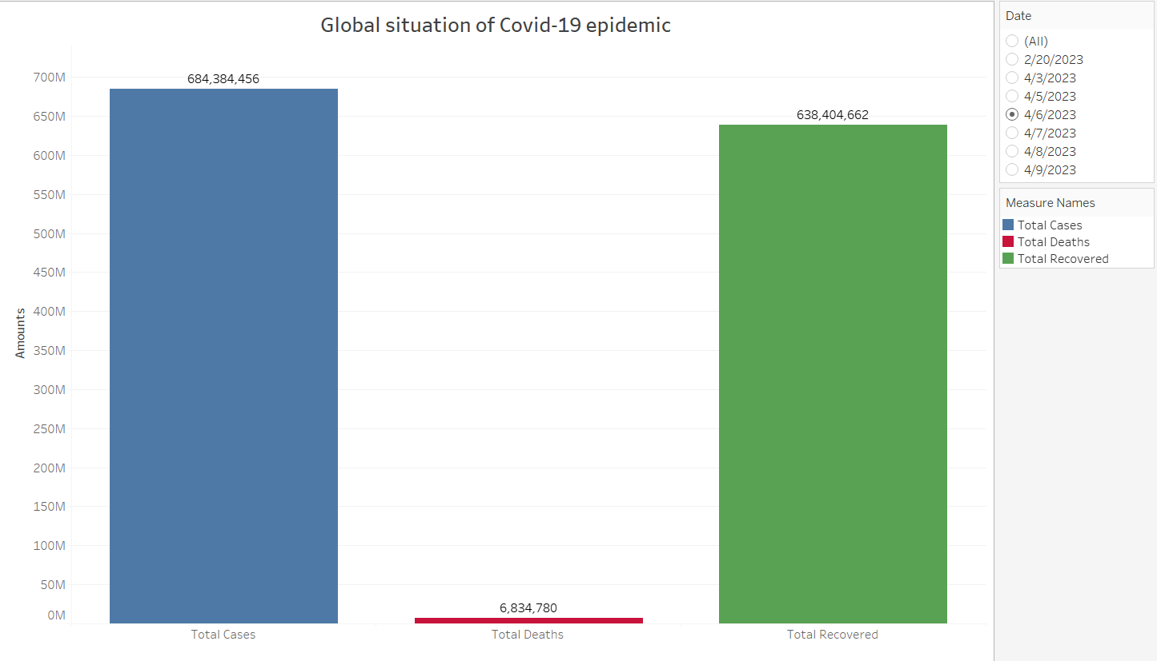

**(View of chart and features)**

**How to do?**

**Field:** *Total Cases, Total Deaths* and *Total Recovered.*

**Color:**  shows details about Total Cases, Total Deaths and Total Recovered.

**The marks:**  are labeled by Total Cases, Total Deaths and Total Recovered.

**The data:**  is filtered on Date, which keeps 4/6/2023.

**Comments:**

* Overview of the worldwide covid-19 epidemic situation through total number of cases, total number of deaths and total number of cured cases.
* We see that the number of deaths accounts for a very small part of the total number of cases and the total number of saved cases. But the total number of cases is huge compared to the global population.

1. Heat map Global situation of Covid-19 epidemic

**Chart**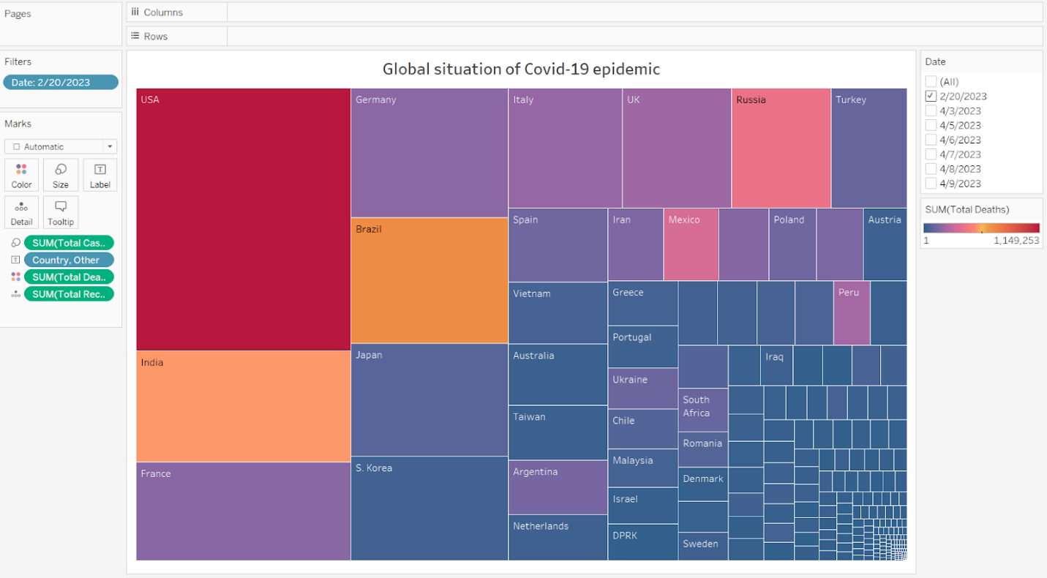

**(Full view of editing)**

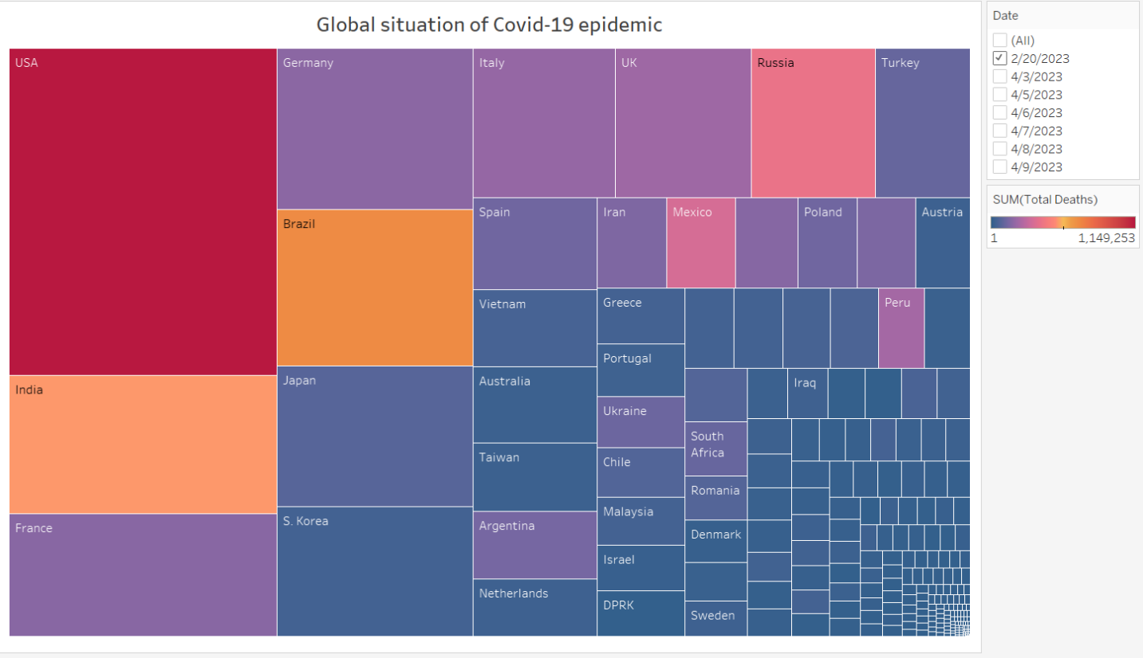

**(View of chart and features)**

**How to do?**

**Field:** *Country, Other*.

**Color:** shows sum of Total Deaths.

**Sizes:**  shows sum of Total Cases.

**The marks:** are labeled by Country, Other.

**The data:**  is filtered on Date, which keeps 2/20/2023.

**Comments:**

* Show the severity of the covid-19 epidemic through visualization of the colors and areas of the countries with the epidemic.

### Analysis

**Note**: Scatter is the most appropriate chart to show correlation between 2 attributes.

1. Relation between Total case and Population

**Chart**

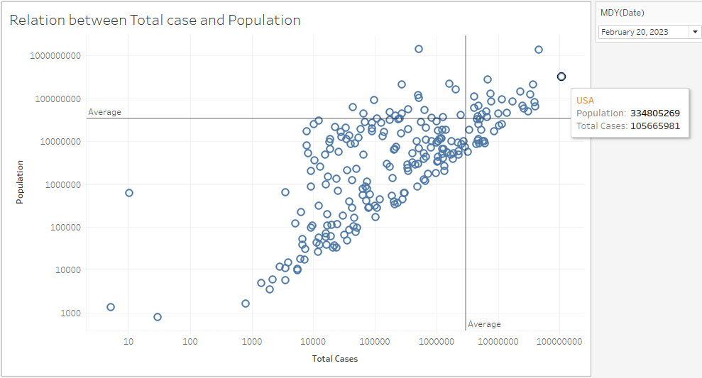

**Comments**

* The higher Population, the higher Total Cases (they have positive linear correlation).
* Many countries have high rates of covid infection (x and y values are almost equal at many points).
* Total cases and Population of countries have big differences (2 Average lines skew to the upper left).

**How to do?**

- Drag 2 attributes to 2 axes, right click and choose Dimension and Continuous:

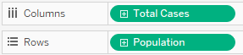

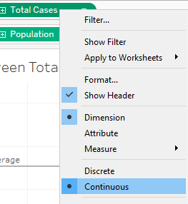

**-** Drag 2 attributes to filter:

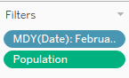

Date: to filter data by date.

Population: to exclude null values.

- Drag Country, Other to Tooltip to show country name when hover:

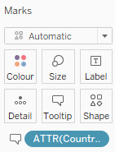

**-** Right click on each column, select Edit Axis, then tick at Logarithmic to scale data.

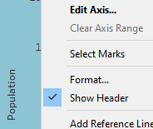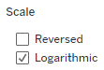

**-** At Analytics, drag Average Line to chart:

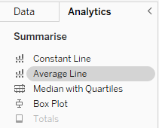 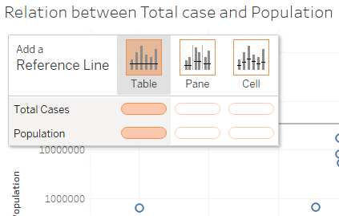

1. Relation between total deaths and total recovered

**Chart**

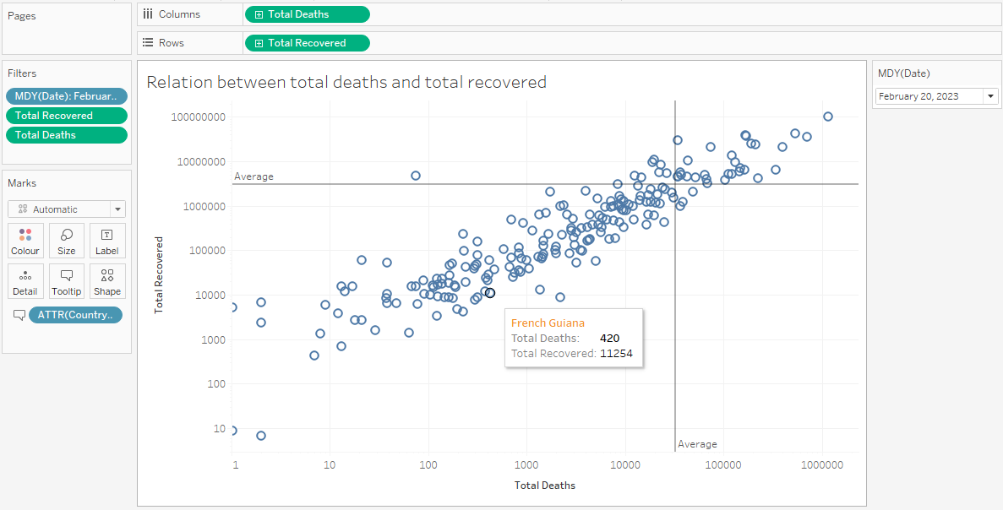

**Comments**

* All countries have more Recovered cases than Death cases.
* The higher Recovered cases, the higher Deaths cases (positive linear correlation).
* Recovered cases and Deaths cases of countries have big differences (2 Average lines skew to the upper left).

**How to do?**

- Do the same as the above chart, but 2 attributes now is:



- And remove null values at both dimensions:

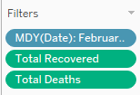

1. Multiple scatter chart Relationship between total cases and others

**Chart**

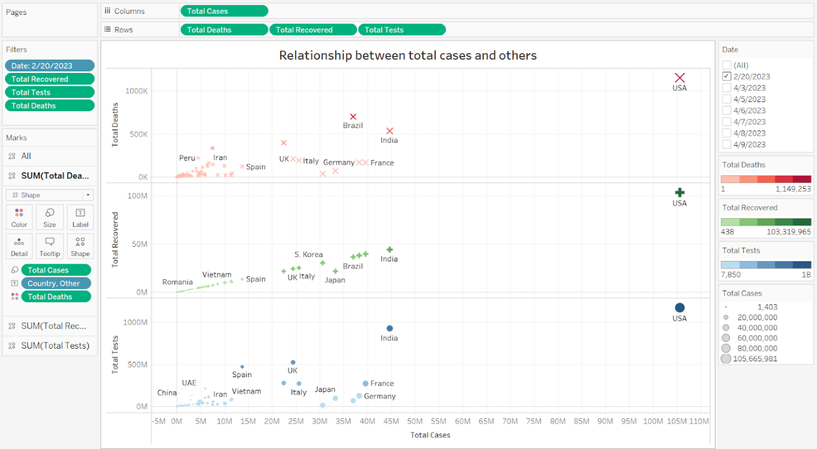

**(Full view of editing)**

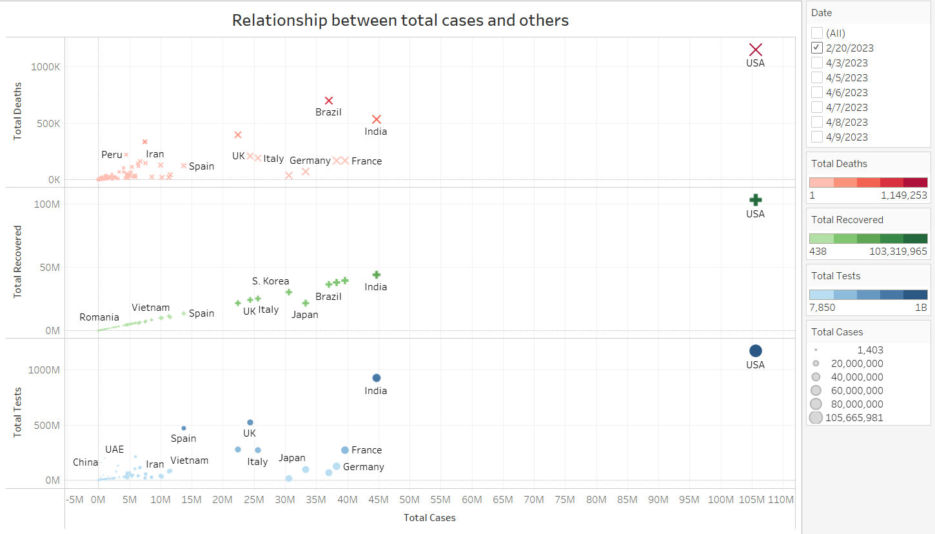

**(View of chart and features)**

**How to do?**

**Field:** *Total Cases* vs *Total Deaths*, *Total Recovered* and *Total Tests*.

**Size:**  shows Total Cases.

**The marks:** are labeled by Country, Other.

**Pane:**

* For pane Total Deaths: Color shows Total Deaths.
* For pane Total Recovered: Color shows Total Recovered.
* For pane Total Tests: Color shows Total Tests.

**The data:**

* The Date filter keeps 2/20/2023.
* The Total Recovered filter keeps non-Null values only.
* The Total Tests filter keeps non-Null values only.
* The Total Deaths filter keeps non-Null values only.

**Comments:**

* When the total number of cases increases, the total number of deaths, the total number of tests, the total number of saved cases all increase at the same time.
* And when we visually see it, it seems that the total number of deaths, the total number of tests, the total number of cases saved have a linear relationship with the total number of cases.
* Special country: The USA leads with total deaths, total tests, total saved cases and total infections.

1. Scatter chart Relationship between serious and active cases

**Chart**

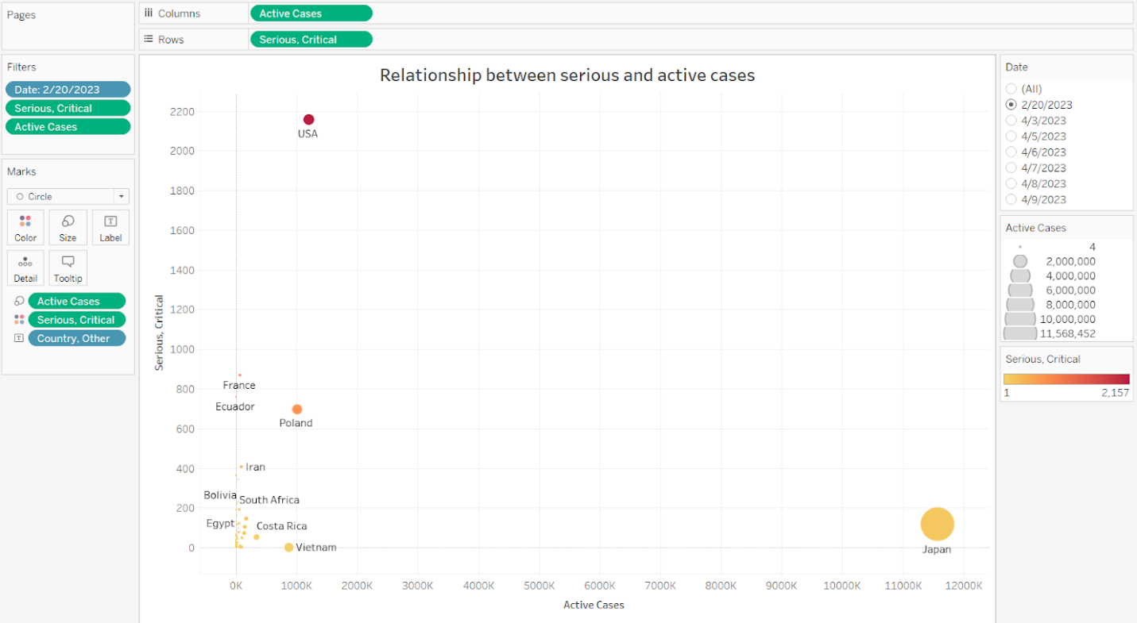

**(Full view of editing)**

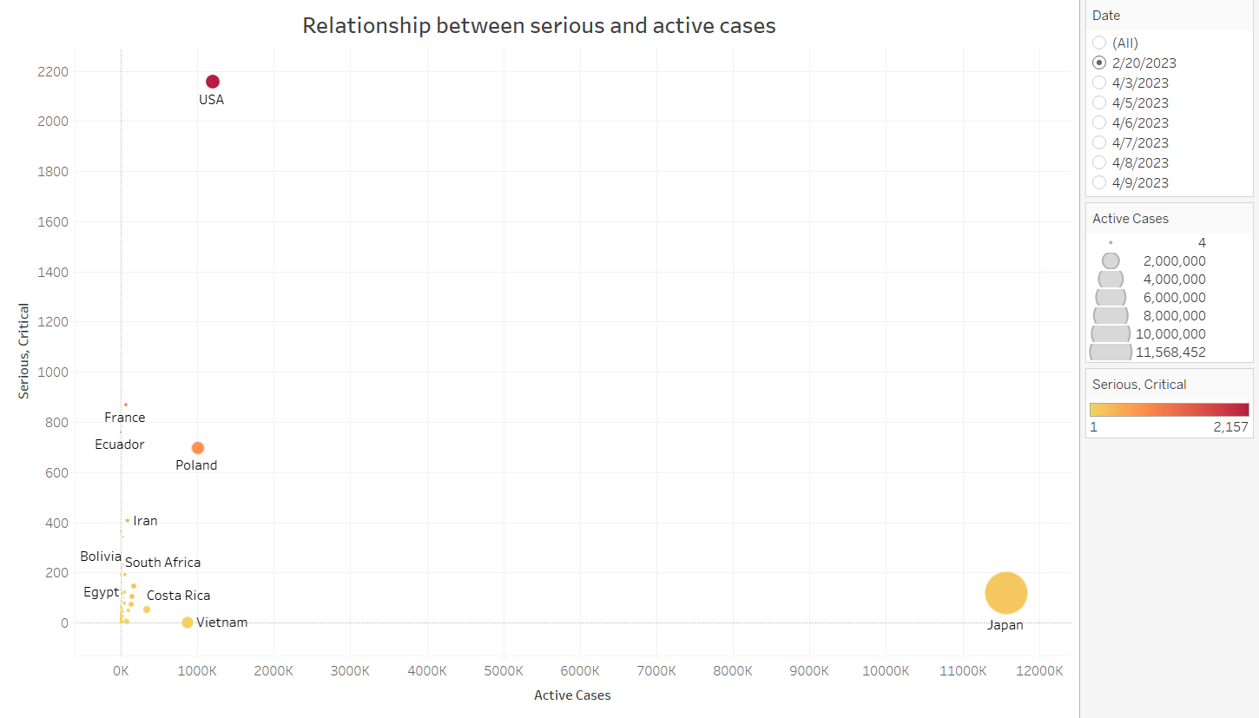

**(View of chart and features)**

**How to do?**

**Field:** *Active Cases* vs. *Serious*, *Critical*.

**Color:**  shows Serious, Critical.

**Size:** shows Active Cases.

**The marks:** are labeled by Country, Other.

**The data:**

* Is filtered on Date, Serious, Critical and Active Cases.
* The Date filter keeps 2/20/2023.
* The Serious, Critical filter keeps non-Null values only.
* The Active Cases filter keeps non-Null values only.

**Comments:**

* Most of the serious and critical case rates compared to the active case rates are very low and these two fields have almost no relationship with each other.
* Some special countries:
* The USA: The total number of serious and critical cases is quite large compared to serious and critical cases of countries with the same number of active cases.
* Japan: the total number of active cases is quite large compared to the active cases of countries with the same number of serious and critical cases.

### Continents

1. Bar mix line chart **Review of total cases**

**Chart**

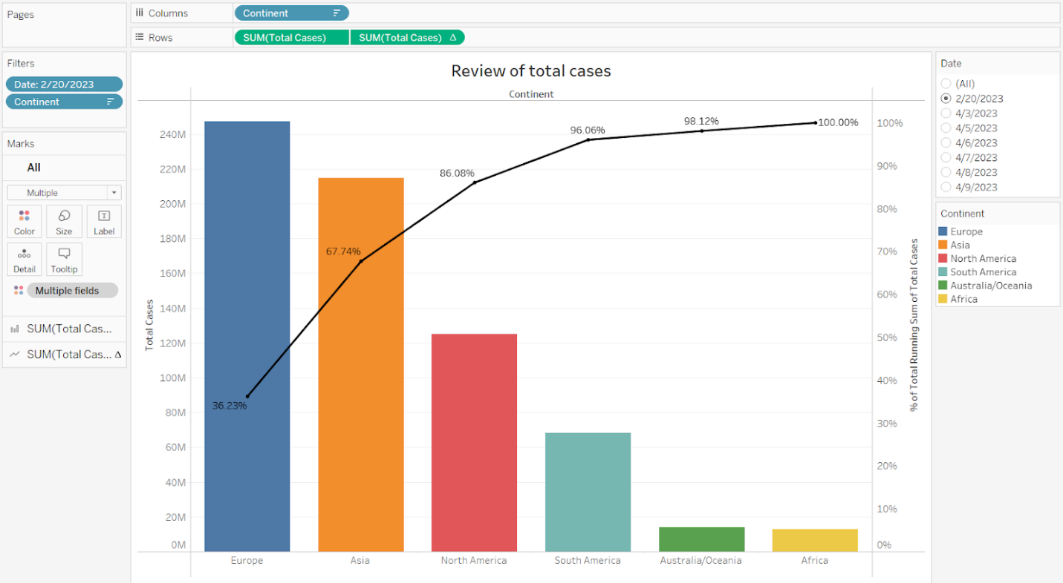

**(Full view of editing)**

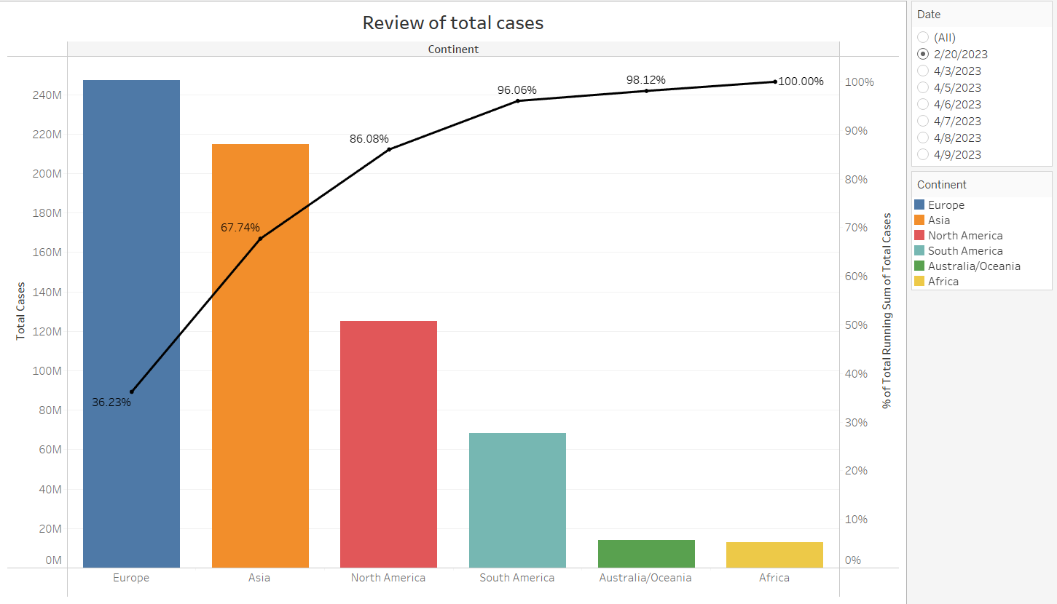

**(View of chart and features)**

**How to do?**

**Field:** *Total Cases*, *Continent*.

The trends of sum of Total Cases and % of Total Running Sum of Total Cases for Continent.

**Pane:** For pane Sum of Total Cases: Color shows details about the Continent.

**The data:**

* The data is filtered on Date, which keeps 2/20/2023.
* The view is filtered on Continent, which excludes Null.

**Comments:**

* The total number of cases increased in order: Africa < Australia/Oceania < South America < North America < Asia < Europe.
* The continents with the largest total number of infections and accounting for a large proportion of the total number of infections worldwide are: North America, Asia, Europe.

1. Bar mix line chart **Review of total deaths**

**Chart**

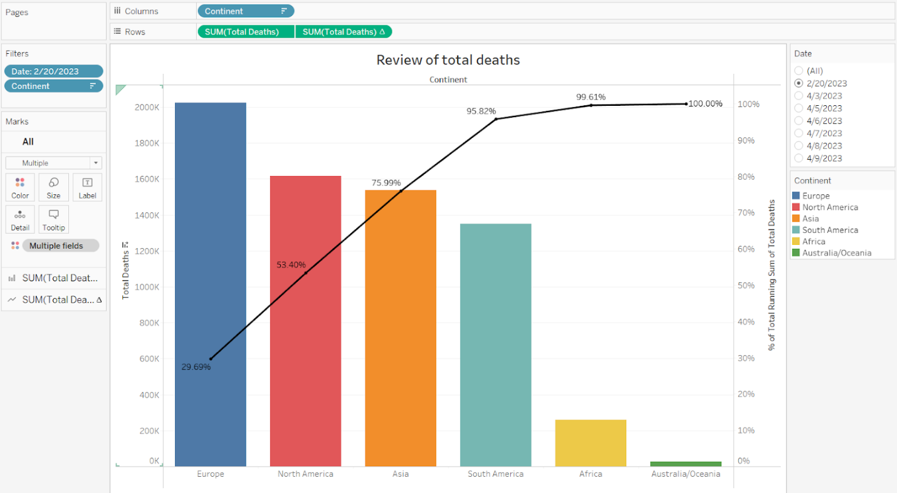

**(Full view of editing)**

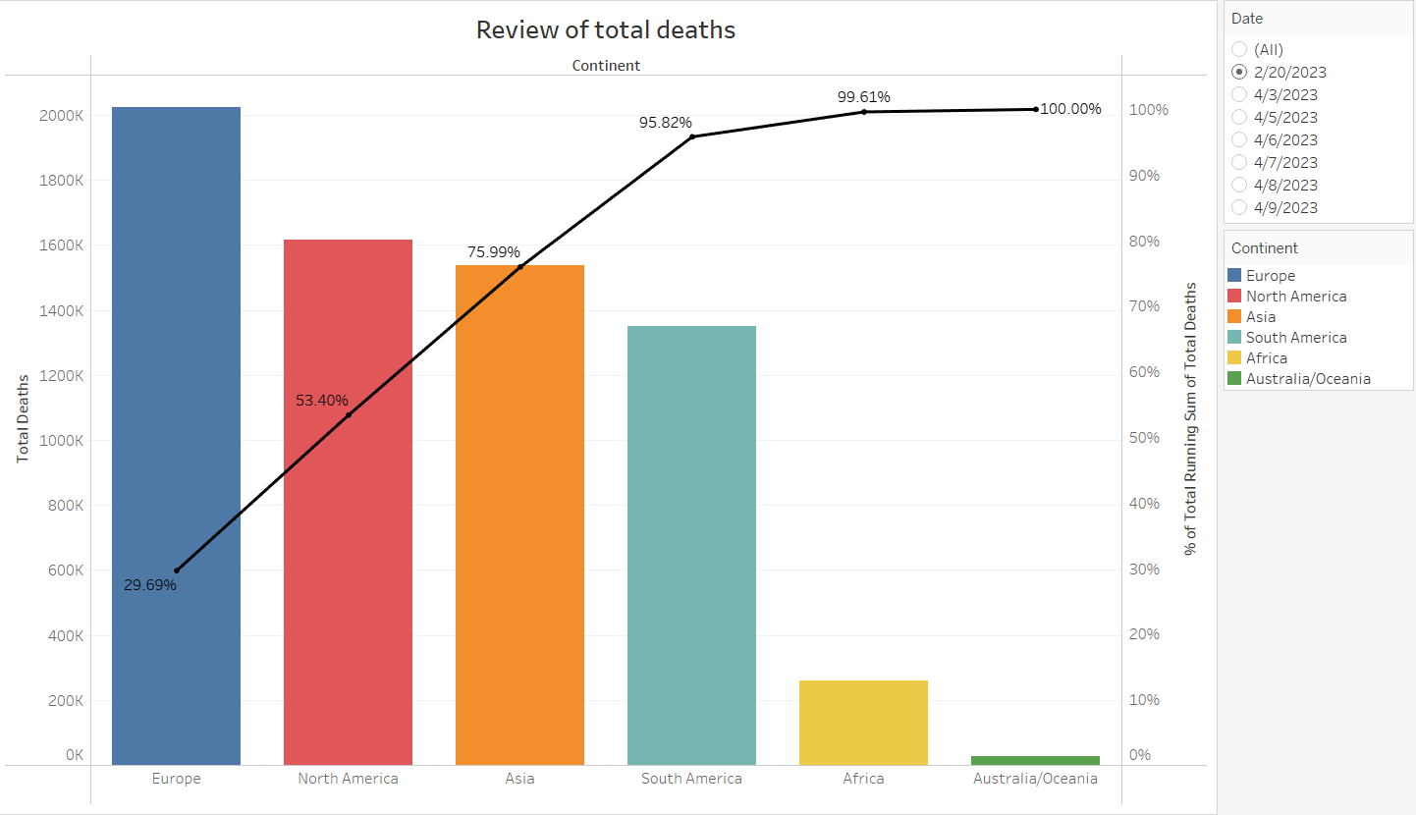

**(View of chart and features)**

**How to do?**

**Field:** *Total Deaths, Continent.*

The trends of sum of Total Deaths and % of Total Running Sum of Total Deaths for Continent.

**Pane:** For pane Sum of Total Deaths:  Color shows details about the Continent.

**The data:**

* The data is filtered on Date, which keeps 2/20/2023.
* The view is filtered on Continent, which excludes Null.

**Comments:**

* The total number of deaths increased in order: Australia/Oceania < Africa < South America < North America < Asia < Europe.
* The continents with the largest total number of deaths and accounting for a large proportion of the total number of deaths worldwide are: North America, Asia, Europe.

1. Bar mix line chart **Review of total recovered**

**Chart**

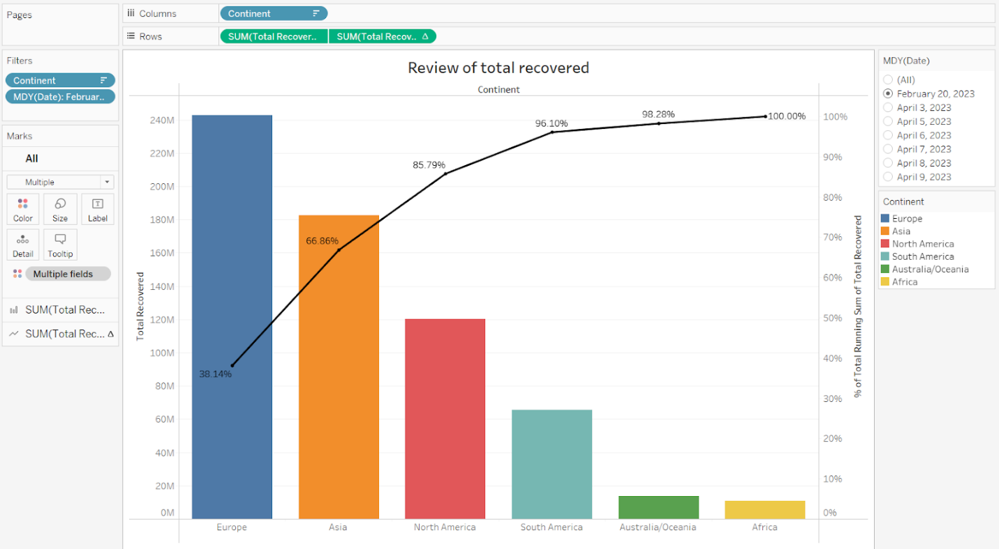

**(Full view of editing)**

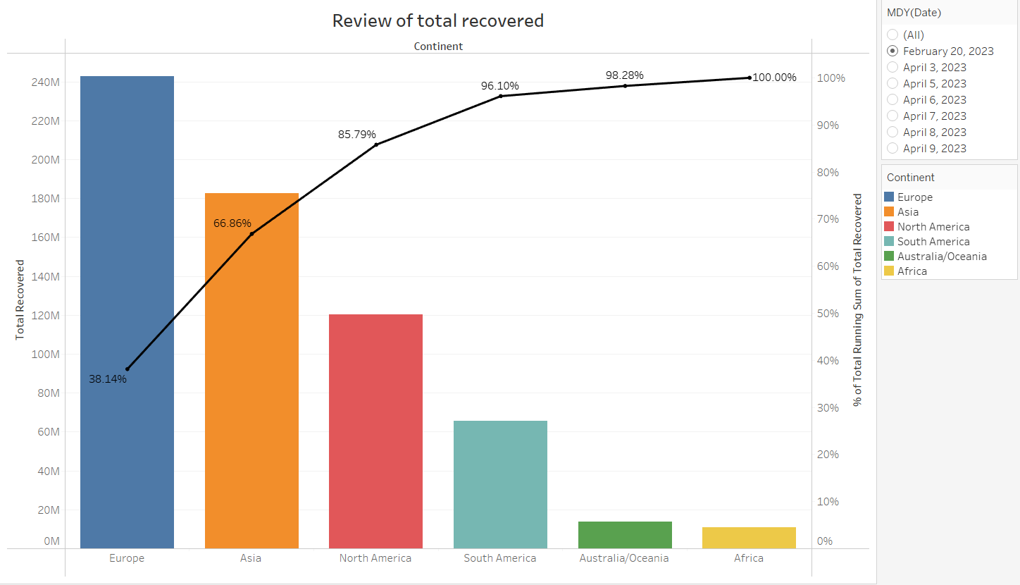

**(View of chart and features)**

**How to do?**

**Field:** *Total Recovered, Continent*.

The trends of sum of Total Recovered and % of Total Running Sum of Total Recovered for Continent.

**Pane:** For pane Sum of Total Recovered:  Color shows details about the Continent.

**The data:**

* The data is filtered on Date (MDY), which keeps February 20, 2023.
* The view is filtered on Continent, which excludes Null.

**Comments:**

* The total number of cured cases increased in order: Africa < Australia/Oceania < South America < North America < Asia < Europe.
* The continents with the largest number of cured cases and a large proportion of the total number of cured cases worldwide are: North America, Asia, Europe.

1. Bar mix line chart **Review of total tests**

**Chart**

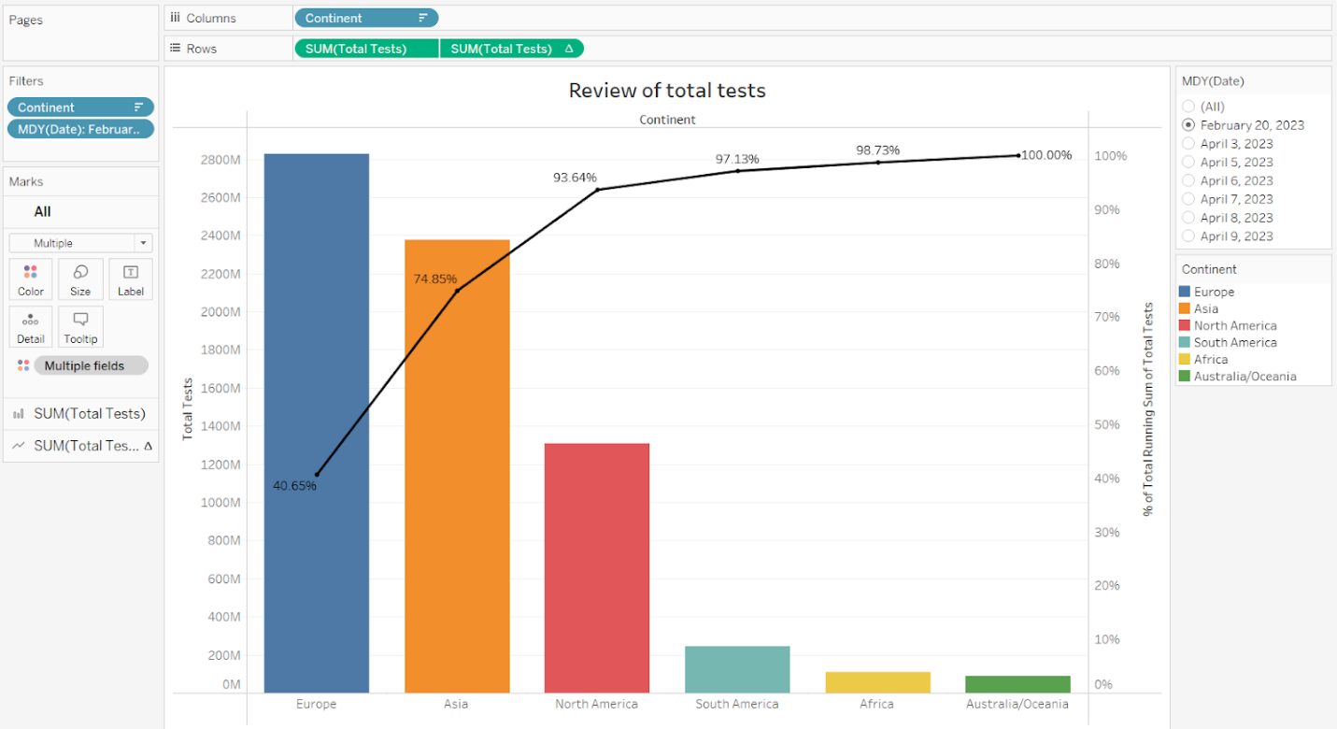

**(Full view of editing)**

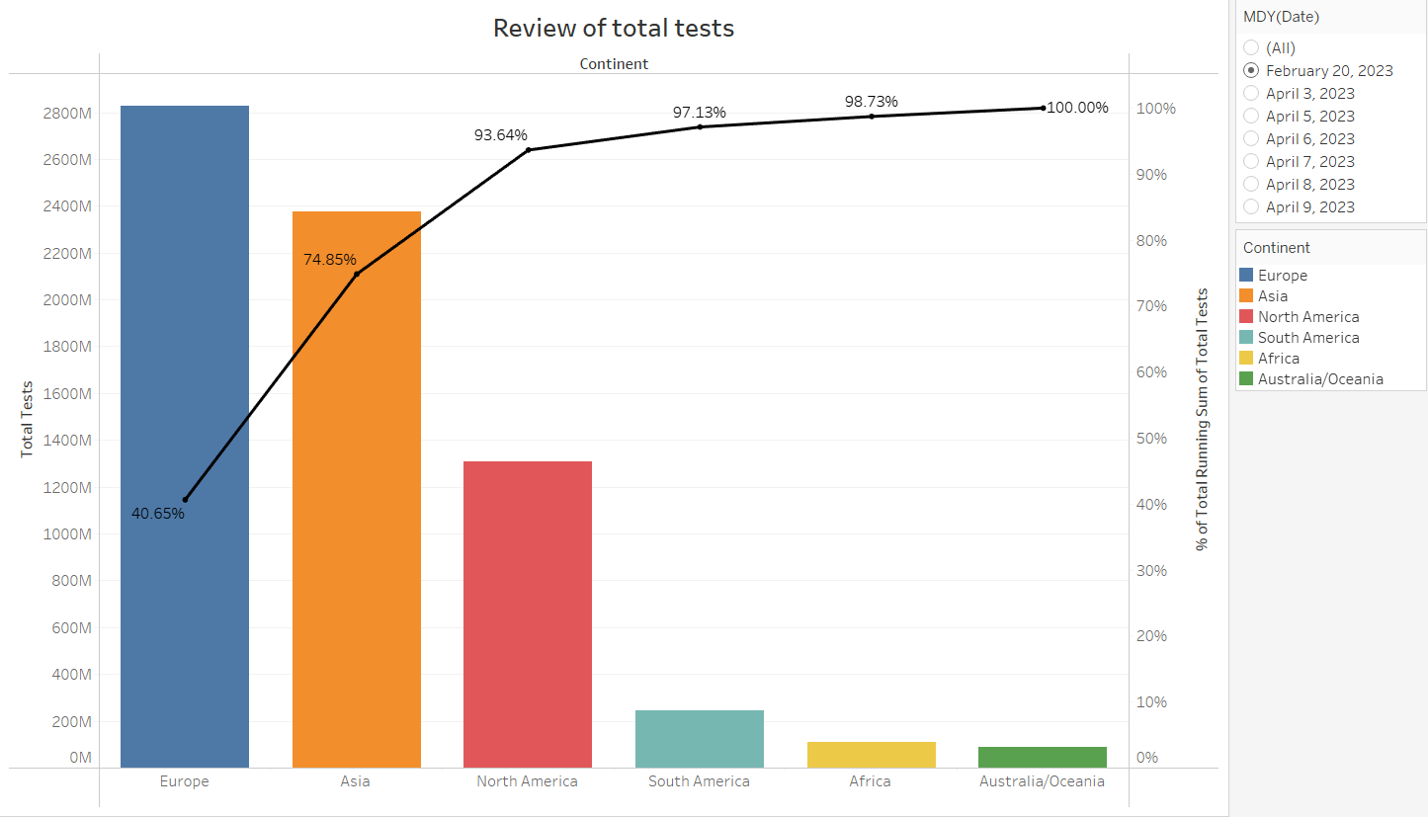

**(View of chart and features)**

**How to do?**

**Field:** *Total Tests, Continent*.

The trends of sum of Total Tests and % of Total Running Sum of Total Tests for Continent.

**Pane:** For pane Sum of Total Tests:  Color shows details about the Continent.

**The data:**

* The data is filtered on Date (MDY), which keeps February 20, 2023.
* The view is filtered on Continent, which excludes Null.

**Comments:**

* The total number of test cases increased in order: Australia/Oceania < Africa < South America < North America < Asia < Europe.
* The continents with a large total number of test cases and accounting for a large proportion of the total number of test cases worldwide are: North America, Asia, Europe.

1. Multiple bar chart **Ratio of case-test-death in each continent**

**Chart**

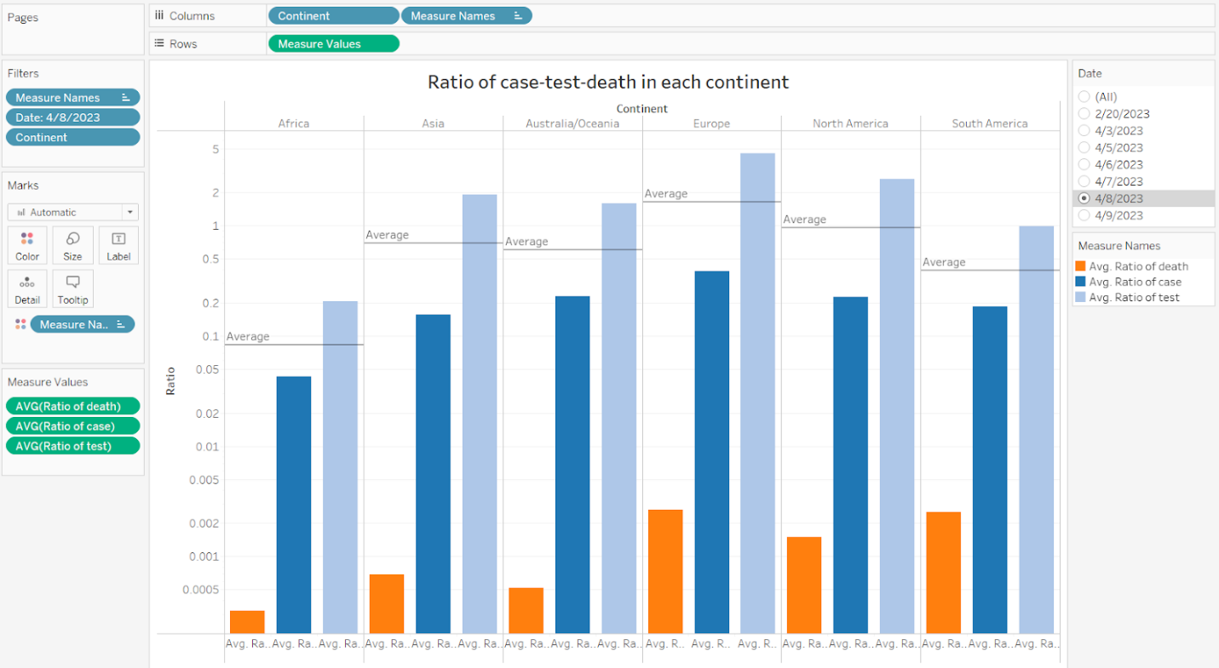

**(Full view of editing)**

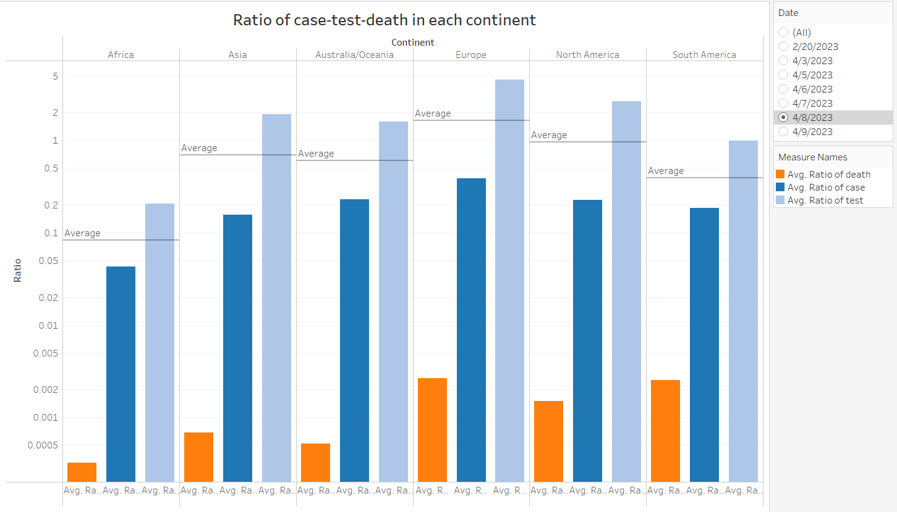

**(View of chart and features)**

**How to do?**

**Field:** *Percentage of death, Percentage of test, Percentage of case.*

Avg. Ratio of death, Avg. Ratio of case and Avg. Ratio of test for each Continent.

**Color:**  shows details about Avg. Ratio of death, Avg. Ratio of case and Avg. Ratio of test.

**The data:**

* The data is filtered on Date, which keeps 4/9/2023.
* The view is filtered on Continent, which excludes Null.

**Comments:**

* In 3 rates: mortality rate, infection rate, test rate; The test rate is always at the highest level, then the morbidity rate, and finally the mortality rate.
* In Europe, on average, these rates are the highest among all continents.
* In Africa, on average, these rates are among the lowest of all continents.

1. Pie chart **Percent of Total Cases by continent**

**Chart**

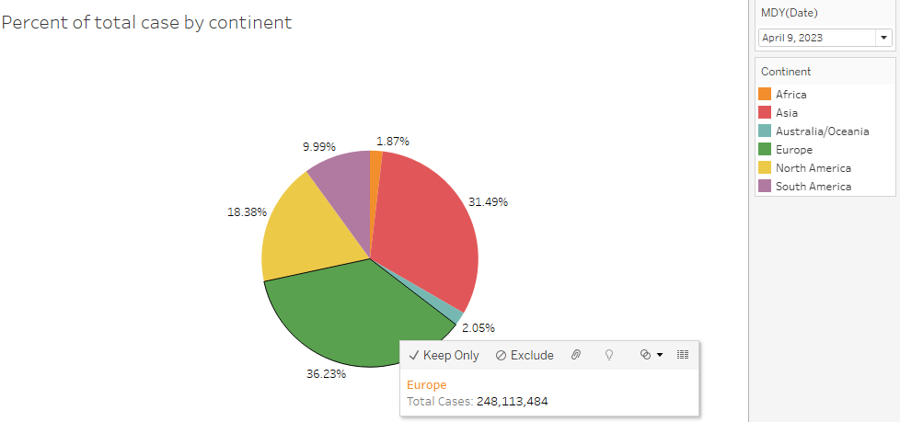

**Comments**

* There is a large disparity between the largest % Total Cases (Europe - 36.23% - 9/4/2023) and the smallest % Total Cases (Africa - 1.87% - 9/4/2023). Meanwhile, Europe is the continent with the most advanced health in the world, and Africa is less developed and has a larger population.
* Is the difference between the number of recorded Total Cases and the actual number of Total Cases in Africa too big?
* Asia is the origin of the disease and the most populous in the world, but it also ranks second in the chart with 31.49% (9/4/2023).

**Note:** the data is virtually unchanged these days.

**How to do**

**-** Change mark to Pie:

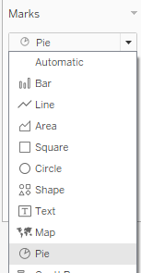

**-** Drag Continent to Colour and Total Cases to Angle:

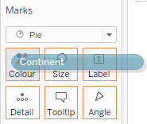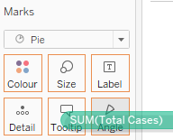

- Change Total Cases to Sum, Add ‘Percent of Total’ calculation:

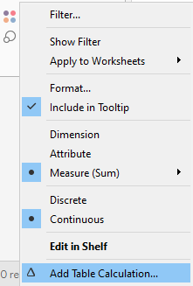 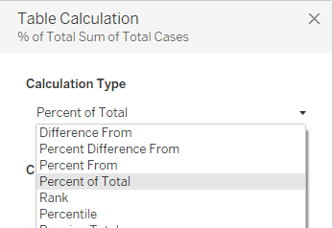

- Drag Sum of Total Cases to Tooltip, then click to Tooltip to custom:

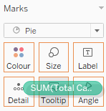 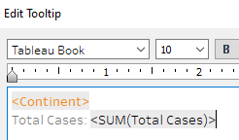

- Drag 2 attributes to filter:

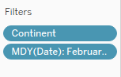

Date: to filter data by date.

Continent: to exclude null values.

1. Pie chart **Percent of Active Cases by continent**

**Chart**

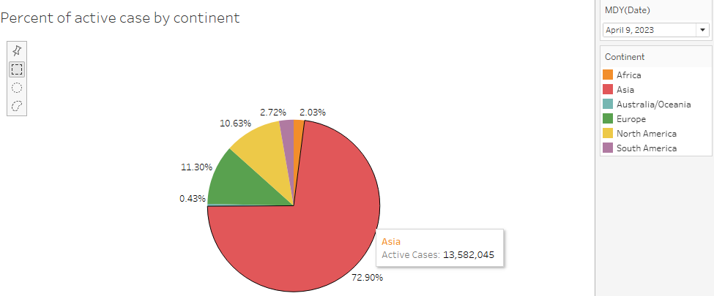

**Comments**

* The epidemic in Asia is still the most intense (highest Active Cases).
* Europe - North America and Africa - South America are close together.
* Australia/Oceania is the lowest because it is a separate continent with a small population.

**How to do**

- Do the same as the 6th chart, but the attribute now is Active Cases:

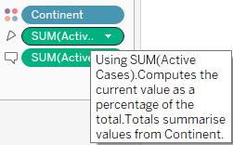

1. Pie chart **Percent of Total Deaths by continent**

**Chart**

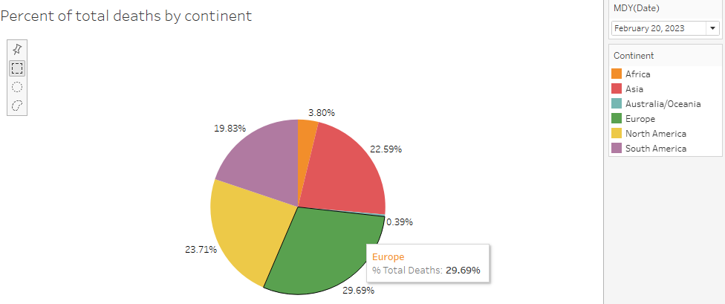

**Comments**

* Total Deaths of Europe, Asia, North America and South America is quite close.
* There is a big difference in the Total Deaths in Australia/Oceania compared to other continents.

**How to do**

- Do the same as the 6th chart, but the attribute now is Total Deaths:

1. Pie chart **Percent of Total Recovered by continent**

**Chart**

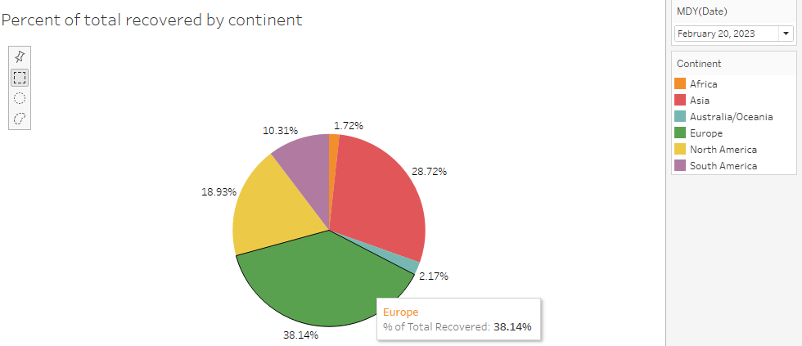

**Comments**

* Total Recovered in Asia and North America is also a reversal compared to the order in the Total Deaths. The remaining continents still keep their respective order in the Total Deaths.

**How to do**

- Do the same as the 6th chart, but the attribute now is Total Recovered:

### Top countries

1. Bar chart **Top 10 Total Cases**

**Chart**

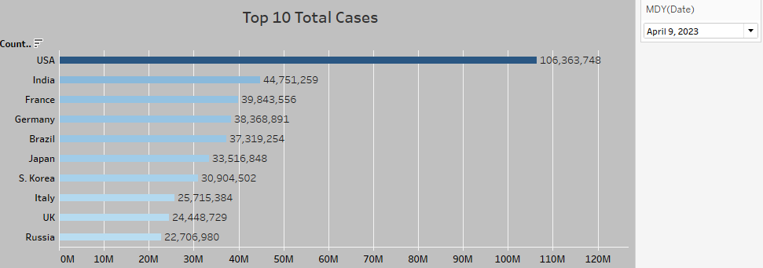

**Comments**

* There is a large disparity between the number of cases in the USA and in the top countries (nearly equal to the sum of the 2nd, 3rd, and 4th countries).
* Although China has the largest population in the world and is the source of the epidemic, it is not in the top 10.
* Half of the top 10 list includes European countries.

**How to do**

- Drag 2 attributes to 2 axes:

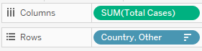

- Drag Total Cases to Colour and Label:

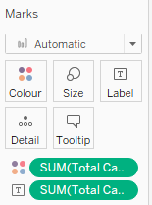

Color: The larger the number, the darker the color

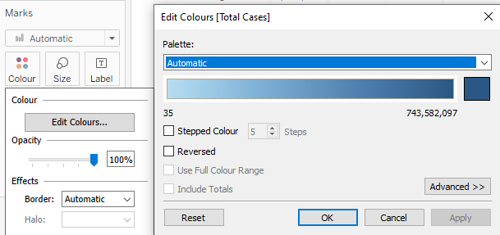

Label to show the data

- Drag Sum of Total Cases to Tooltip, then click to Tooltip to custom:

 

- Drag 2 attributes to filter:

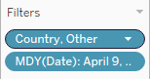

Date: to filter data by date.

Country, Other: to exclude null values and filter top 10 (after sorting chart).

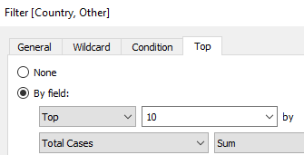

2. Bar chart **Top 10 Total Deaths**

**Chart**

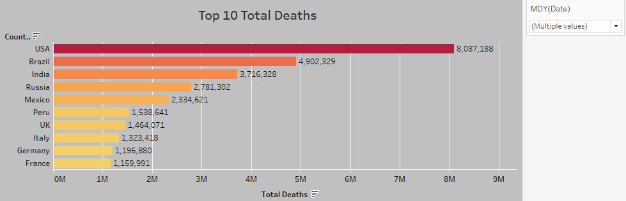

**Comments**

* The USA also leads the world in the number of deaths (double the 2nd), Although they have a modern medical background.
* Although not appearing in the top 10 of cases, some South American countries have a large number of deaths.

**How to do**

- Do the same as the 6th chart, but the attribute now is Total Deaths and choose a different color.

3. Bar chart **Top 10 Total Recovered**

**Chart**

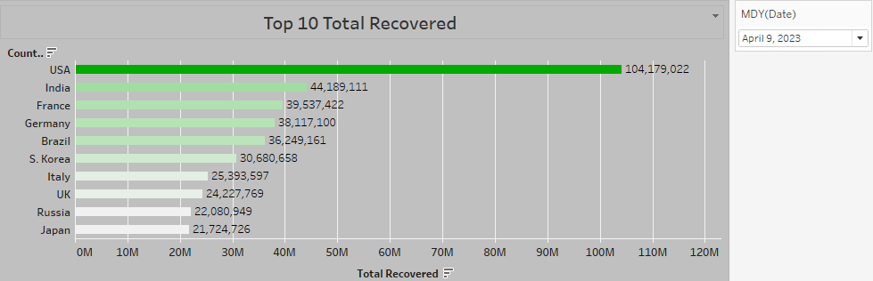

**Comments**

* The USA also leads the world in the number of recovered (nearly the sum of the 2nd, 3rd and 4th countries).

**How to do**

- Do the same as the 1st chart, but the attribute now is Total Recovered and choose a different color.

4. Bar chart **Top 10 Active Cases**

**Chart**

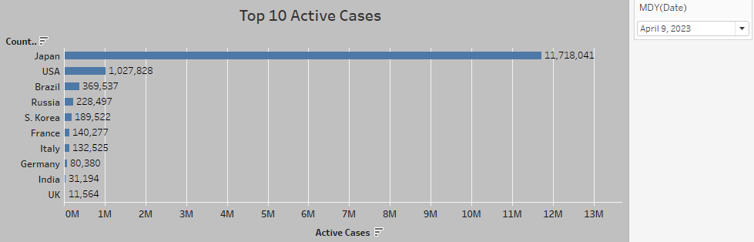

**Comments**

* + Japan now has the largest number of cases under treatment.
  + There is a large disparity between the number of Active Cases in Japan and the other countries.
  + It can be concluded that the epidemic situation is tense in Japan.

**How to do**

- Do the same as the 1st chart, but the attribute now is Active Cases and choose a different color.

5. Bar chart **Top 20 countries with the most ratio of cases per population**

**Chart**

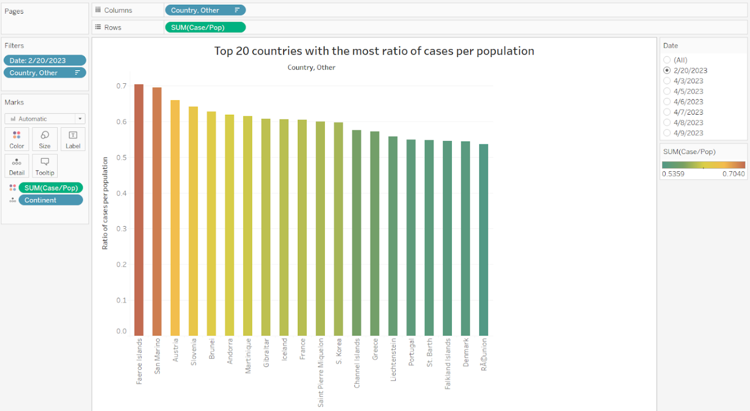

**(Full view of editing)**

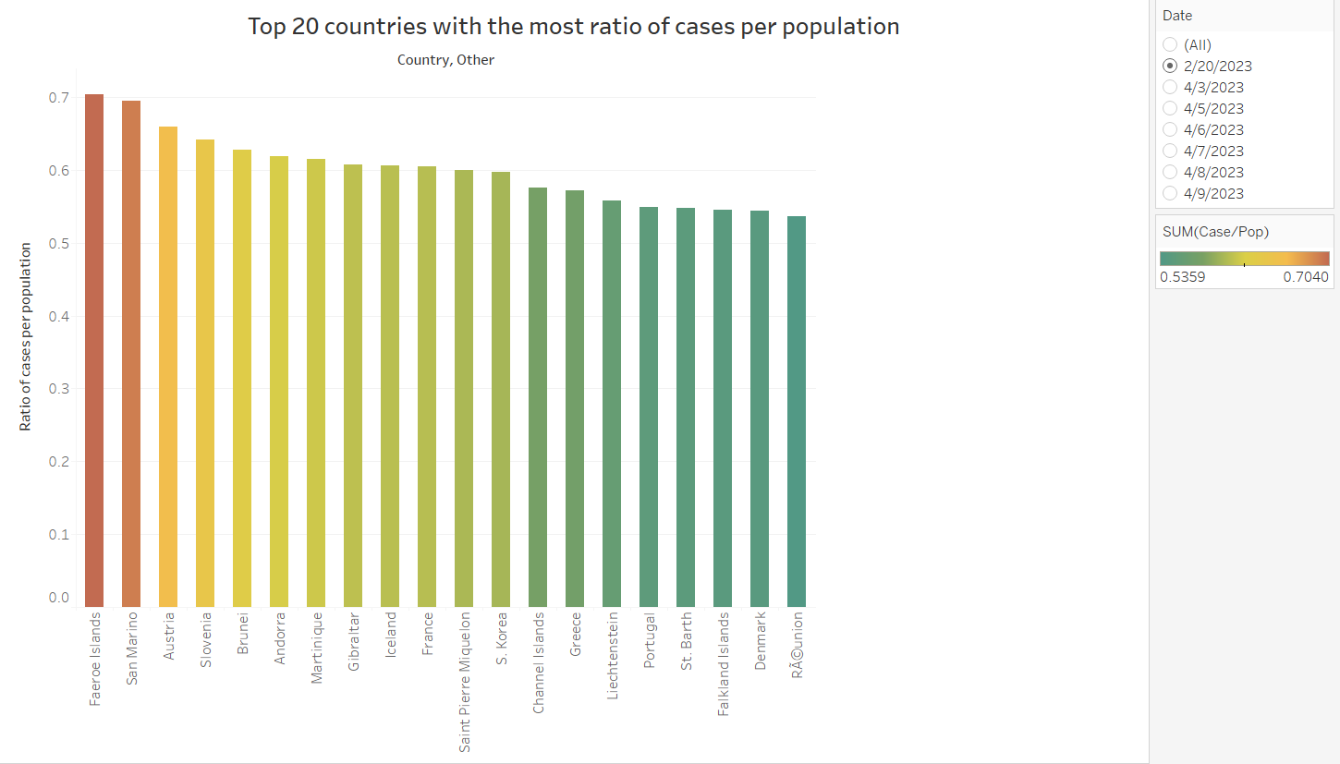

(**View of chart and features)**

**How to do?**

**Field:** *Case/Pop, Country, Other.*

**Color:** shows sum of Case/Pop.

**Details:** are shown for the Continent.

**The data:**

* The data is filtered on Date, which keeps 2/20/2023.
* The view is filtered on Country, Other, which keeps 20 of 231 members.

**Comments:**

* These top 20 countries have a fairly large incidence of the disease, almost greater than 50 percent of the population, some of which include re-infections, but these figures represent the severity of the covid-19 epidemic for the country are extremely large.

### Time series (by day)

1. Bar mix line chart **Change of total cases**

**Chart**

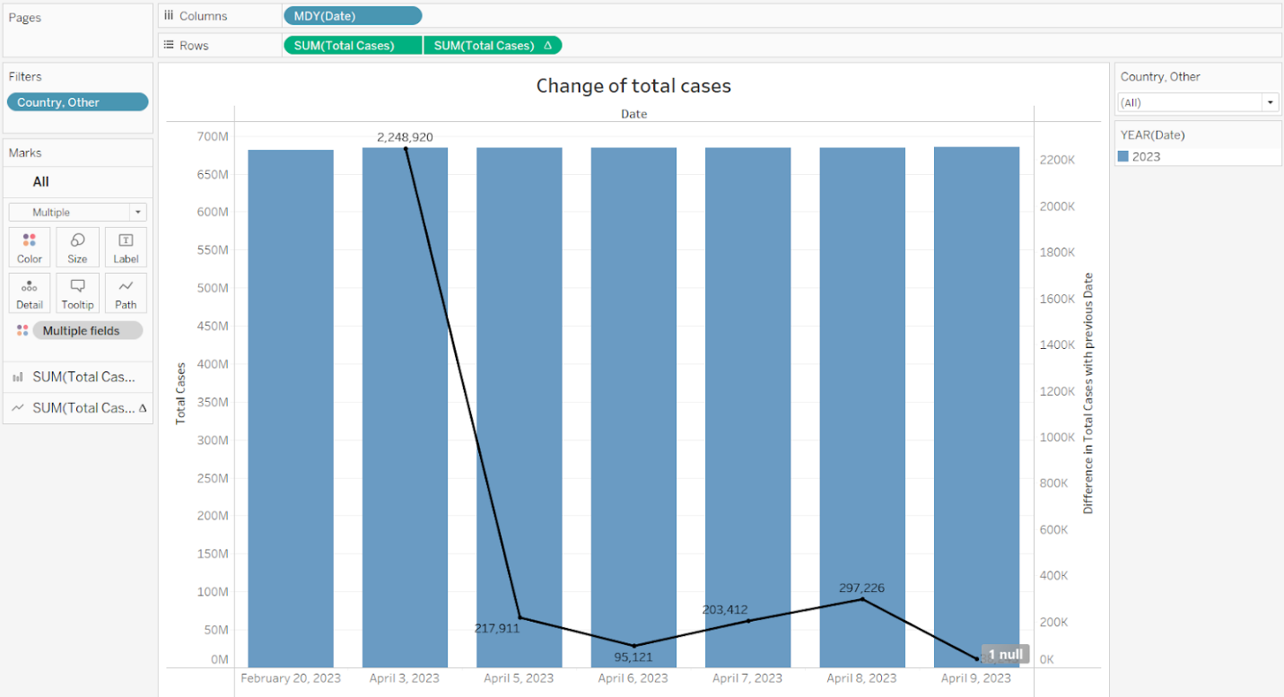

**(Full view of editing)**

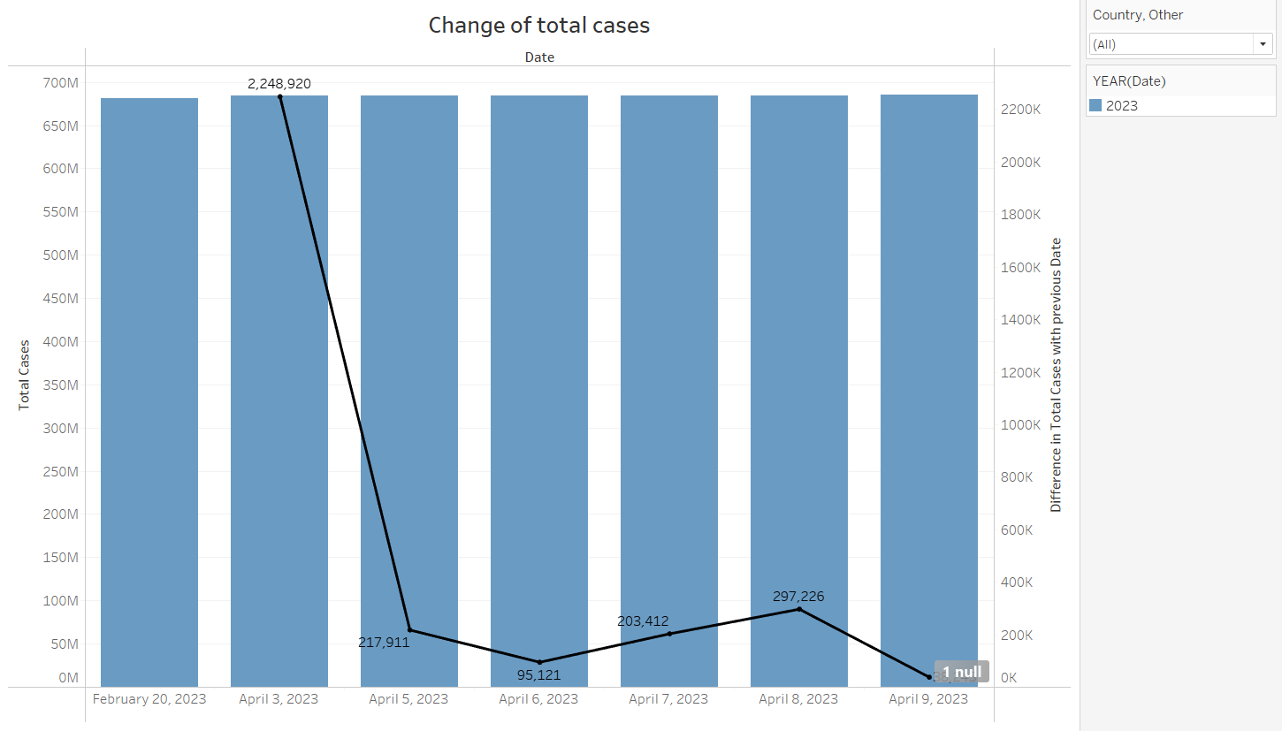

**(View of chart and features)**

**How to do**

**Field:** *Date, Total Cases.*

The trends of sum of Total Cases and Difference in Total Cases for Date (MDY).

**Pane:** For pane Sum of Total Cases:  Color shows details about Date Year.

**The data:** is filtered on Country, Other, which keeps 231 of 231 members.

**Comments:**

* The total number of cases changed greatly between February - 20 - 2023, April - 3 - 2023 and April - 5 - 2023. The total number of cases decreased sharply from February - 20 to April - 5, but increased sharply from April - 6 to April - 8, then fell sharply again from April - 8 to April - 9.

1. Bar mix line chart **Change of total deaths**

**Chart**

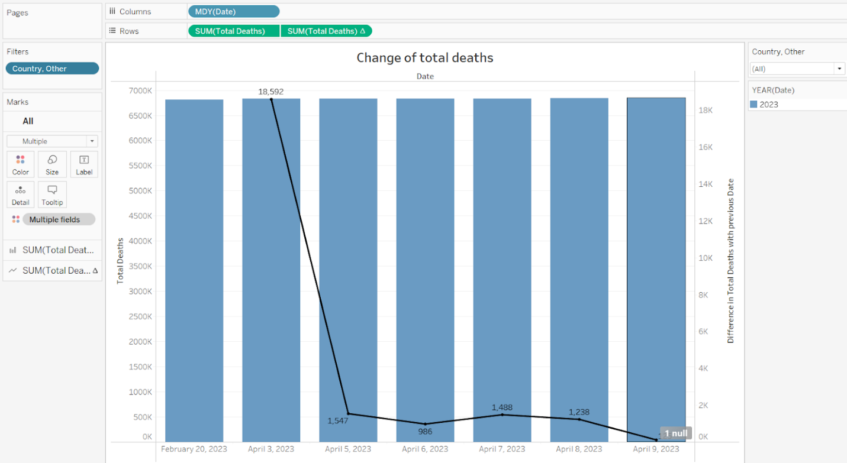

**(Full view of editing)**

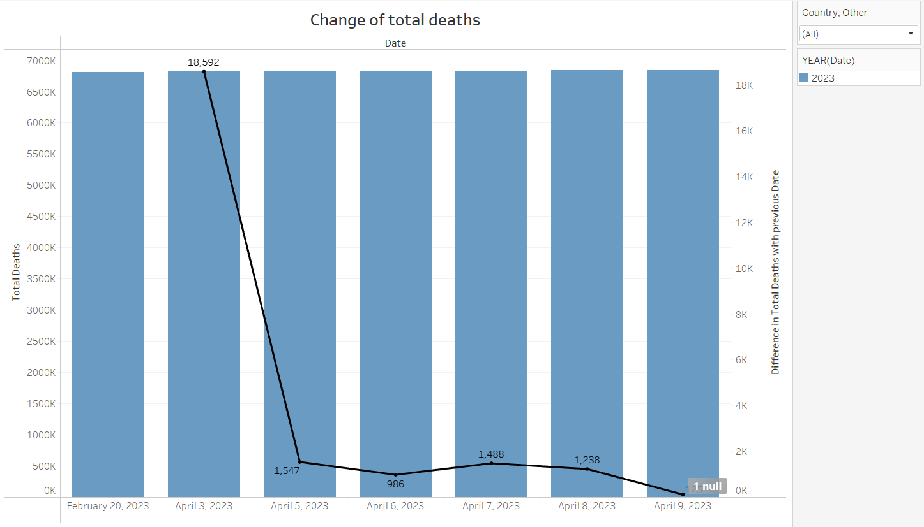

**(View of chart and features)**

**How to do**

**Field:** *Date, Total Deaths.*

The trends of sum of Total Deaths and Difference in Total Deaths for Date (MDY).

**Pane:** For pane Sum of Total Deaths:  Color shows details about Date Year.

**The data:** is filtered on Country, Other, which keeps 231 of 231 members.

**Comments:**

* The total number of deaths had a great change between February - 20 - 2023, April - 3 - 2023 and April - 5 - 2023, the total number of patients treated decreased sharply from February - 20 to April - 5. The total number of deaths in the remaining days has increased and decreased but small.

1. Bar mix line chart **Change of total recovered**

**Chart**

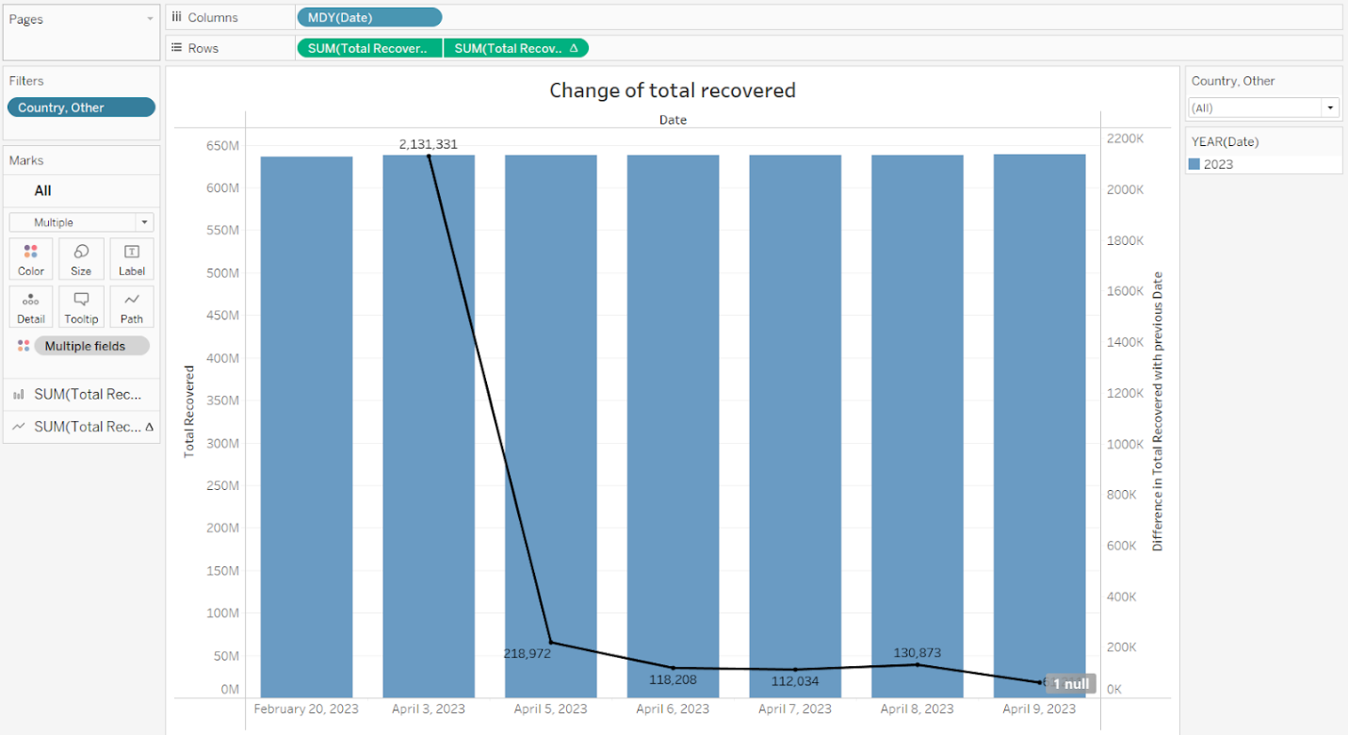

**(Full view of editing)**

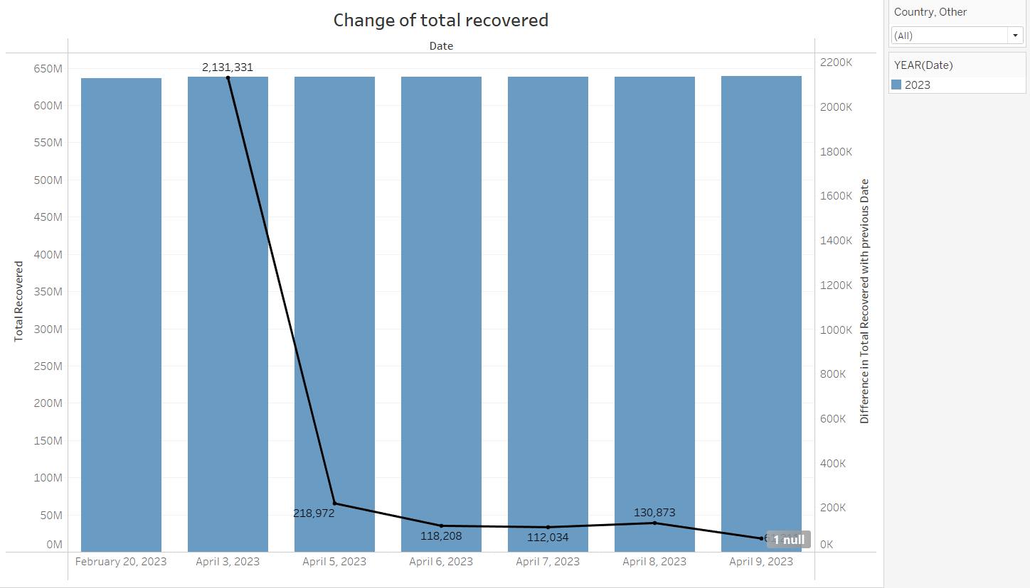

**(View of chart and features)**

**How to do**

**Field:** *Date, Total Recovered.*

The trends of sum of Total Recovered and Difference in Total Recovered for Date (MDY).

**Pane:** For pane Sum of Total Recovered:  Color shows details about Date Year.

**The data:** is filtered on Country, Other, which keeps 231 of 231 members.

**Comments:**

* The total number of treated cases had a big change between February - 20 - 2023, April - 3 - 2023 and April 5 - 2023, the total number of cured cases decreased sharply from February - 20 to April - 5. In the remaining days, the number of saved cases decreased but at a low level.

### Dashboard

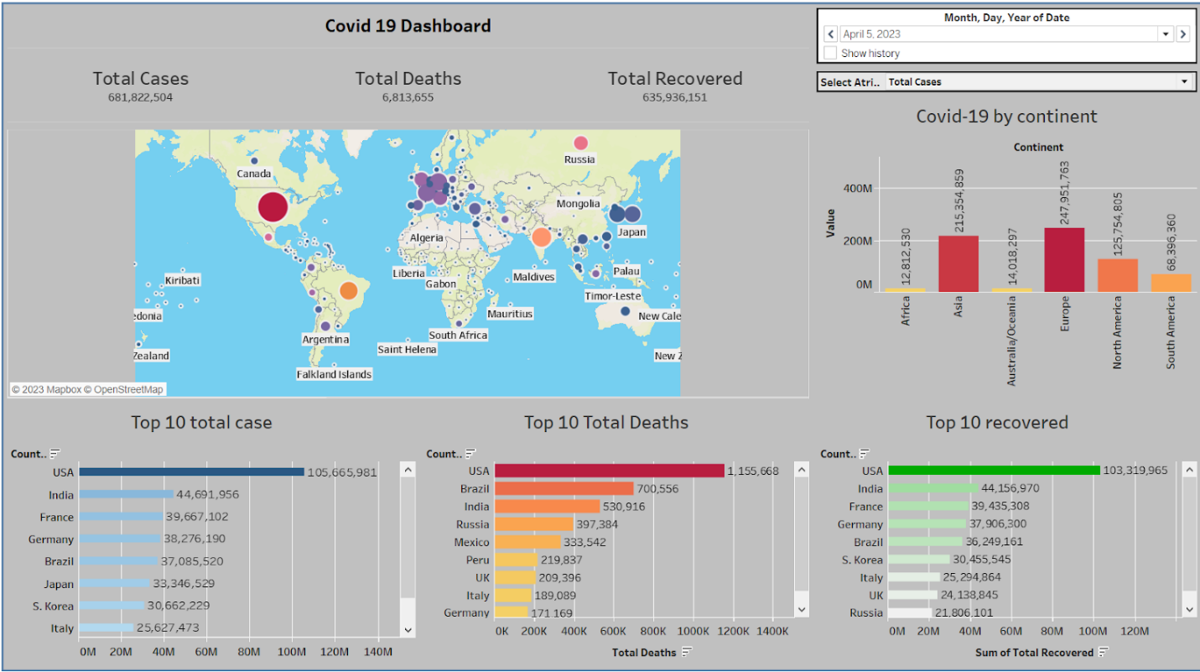

1. Comment:

* Covid-19 data on dashboard filtered by date, so customer can select date (format Month - Day - Year).
* Dashboard provides users with information about covid-19 in the world, continents, and top countries.
* In chart Covid-19 by continent, user can select: total case, total deaths, total recovered, chart show values based on continent.
* The bottom half of the dashboard shows top 10 countries total case total deaths and total recovered.

### Why do we use color for all charts?

* Because these colors represent the degree (more or less, serious or less serious, ...) of the attribute we are referring to, and at the same time it helps to distinguish different attributes one at a time in an intuitive way.
* Therefore, we added color to make the visuals more vivid and intuitive for the viewer.
* And depending on the type of graph, each type of message that we want to send in the graph, we will choose the appropriate colors.

# References

[Tableau Document](https://help.tableau.com/current/pro/desktop/en-us/gettingstarted_overview.htm)

sqlbelle, January 18, 2021. [Tableau Filter](https://www.youtube.com/watch?v=DVTFvmoUnlE&t=20s).

Simplilearn, September 9, 2021. [Covid-19 Data Analysis Project.](https://www.youtube.com/watch?v=DJofs2JyIVM)